**Report about conducted load test**

**Date:** 04/07/2022

**Author:** Vladyslav Kliucharov

**Application:** BlogEngine.NET version 3.2

**Environment:** Test Environment VirtualBox (Version 6.1.34 r150636 (Qt5.6.2))

**Test Environment configuration(RAM, CPU etc.):**

|  |  |
| --- | --- |
| **Processor** | 11th Gen Intel(R) Core(TM) i7-1185G7 @ 3.00GHz 3.00 GHz (4 core) |
| **RAM** | 4 GB |
| **Hard Disk** | 60 GB |
| **Operating System** | Windows 10 Enterprise (21H2) |

1. **Why such testing was conducted:**

The report is included two methods of testing:

1. Smoke testing - was conducted to verification that the crucial functions of a program can be run and executed in the main workflow

2. Load testing - was conducted to define how the application behaves during normal loads

1. **Test script description:**

The features to be tested have been logically grouped to be covered by 3 threads of users "Admin script", "Editor script" and "Anonymous script". These scenarios were combined in one script followed by load requirement analysis for the modules. The below table captures the features covered by each script. The implement probabilities usage was divided by percentages for all threads (shown below tables):

|  |  |
| --- | --- |
| **Admin script** | **Editor script** |
|  |  |

|  |  |  |
| --- | --- | --- |
|  | **Anonymous script** |  |
|  |  |  |

Scenario to implement probabilities usage:

|  |  |
| --- | --- |
| 1. Home Page: 15%  2. Open Random Date: 10%  3. Open Predefined Date: 30%  4. Search by Name: 30%  5. Open Large Calendar: 10%  6. Open Contacts: 5% | 1. Open Random page (yes/no): 50% / 50%  2. Open post (yes/no): 80% / 20%  3. Random or First (yes/no): 65% / 35%  4. Comment (yes/no): 20% / 80% |

1. **Tests:**  
   **Test run preconditions:**

* CSV file with Random dates
* Warmup script was running before each test run
* Before each new test script run, the webserver was reloaded, the test executed in NON-GUI mode

Scenarios model (was used similarly for all scale) the value was getting from Task7 regular load model by got results of previous test runs

|  |  |  |  |  |  |
| --- | --- | --- | --- | --- | --- |
| **Thread Group** | **Maximum number of simultaneous users** | **Ramp-Up period** | **Test duration** | **Probabilities usage** | **Number of posts** |
| Thread Group (Admin users) | 2 | 100 | 600 (sec.) | Pre-Defined | 100, 1000, 2000, 5000 |
| Thread Group (Editor users) | 10 | 50 |  | | |
| Thread Group (Anonymous users) | 35 | 175 |

1. **Short summary on conducted tests:**

The server worked stable according to the received test results. For the tests generated 5000 posts, and the combination of the test was divided by 6 configurations. The first part consists of 4th combinations of 100, 1000, 2000, 5000 without images, and 2nd part of combinations was defined as 1000 posts with images by 1MB and 2000 posts mixed: 1000 with images and 1000 with text. All scenarios were running 2 times for clarifying the results. Test result for 100 posts shows a lower "Error rate" of 0.02%. For 1000 posts with text and 1000 posts with images result shows an "Error rate" of 0.11%, for 2000 posts with text and 2000 mixed posts results show an "Error rate" shows 0.55%. In the case of 5000 posts the highest "Error rate" of 5.40%.

1. **Detailed test results:**

‘Task9’ scripts were running 12 times with different post quantities from 100 to 5000, results fetch in the below table:

|  |  |  |  |  |  |  |  |  |  |  |  |  |
| --- | --- | --- | --- | --- | --- | --- | --- | --- | --- | --- | --- | --- |
|  | **Run 1** | **Run 2** | **Run 3** | **Run 4** | **Run 5** | **Run 6** | **Run 7** | **Run 8** | **Run 9** | **Run 10** | **Run 11** | **Run 12** |
| **Number of posts** | 100 | 100 | 1000 | 1000 | 1000 (Images) | 1000 (Images) | 2000 | 2000 | 2000 (Mixed) | 2000 (Mixed) | 5000 | 5000 |
| **Throughput (Max)** | 16.40 Req/s | 11.80 Req/s | 16.60 Req/s | 15.90 Req/s | 17.00 Req/s | 17.70 Req/s | 16.60 Req/s | 16.00 Req/s | 15.00 Req/s | 15.60 Req/s | 14.60 Req/s | 15.20 Req/s |
| **Error rate** | 0 | 0.02% | 0.04% | 0.11% | 0.11% | 0.05% | 0.55% | 0.39% | 0.53% | 0.52% | 5.40% | 3.68% |
| **Response time (Average)** | 2.52 ms | 2.53 ms | 3.66 ms | 3.46 ms | 3.89 ms | 3.62 ms | 3.89 ms | 3.82 ms | 3.43 ms | 3.87 ms | 2.91 ms | 3.22 ms |
| **Response time (Median)** | 2.03 ms | 2.05 ms | 2.71 ms | 2.59 ms | 2.91 ms | 2.72 ms | 2.83 ms | 2.78 ms | 2.62 ms | 2.89 ms | 2.22 ms | 2.44 ms |
| **90th Percentile (Mean)** | 6.32 sec | 6.82 sec | 2.47 sec | 2.15 sec | 1.35 sec | 2.21 sec | 1.36 sec | 1.52 sec | 3.16 s | 1.50 s | 3.68 s | 2.99 s |
| **95th Percentile (Mean)** | 7.51 sec | 8.18 sec | 3.08 sec | 2.60 sec | 1.71 sec | 2.87 sec | 1.70 sec | 1.95 sec | 4.26 s | 1.93 s | 4.54 s | 3.75 s |

**Test Run #1**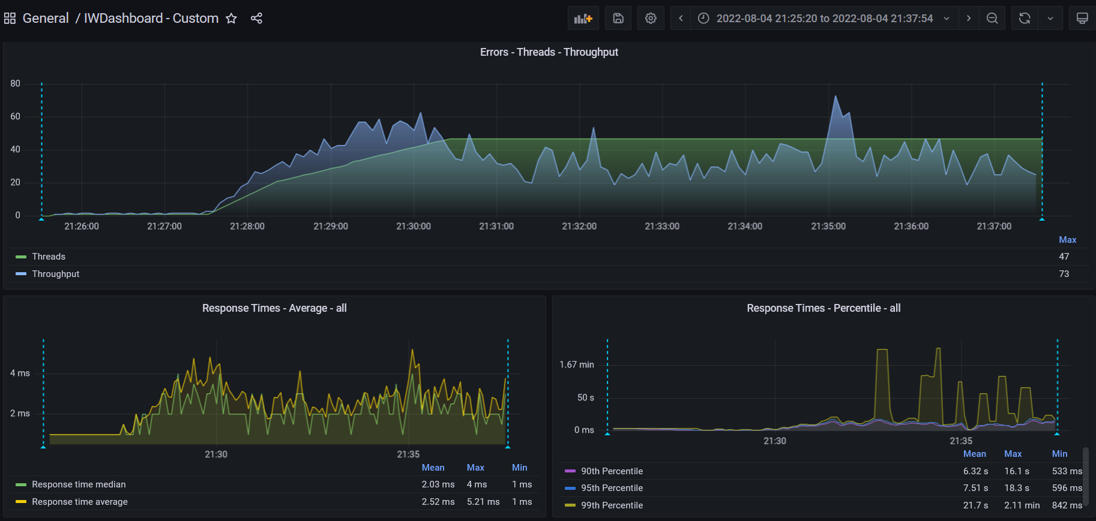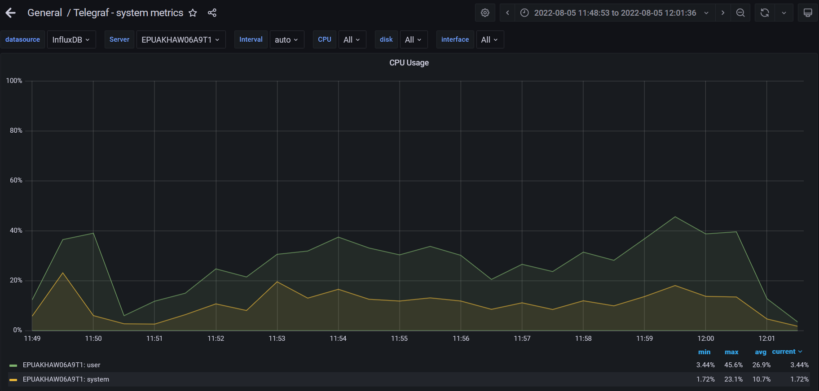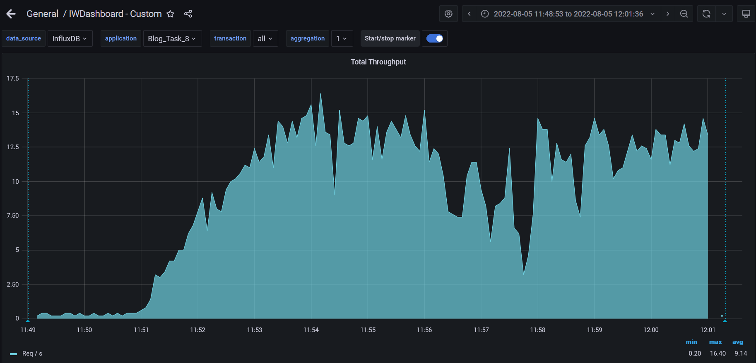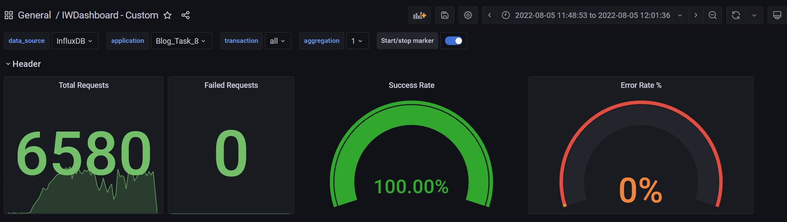

**Test Run #2** 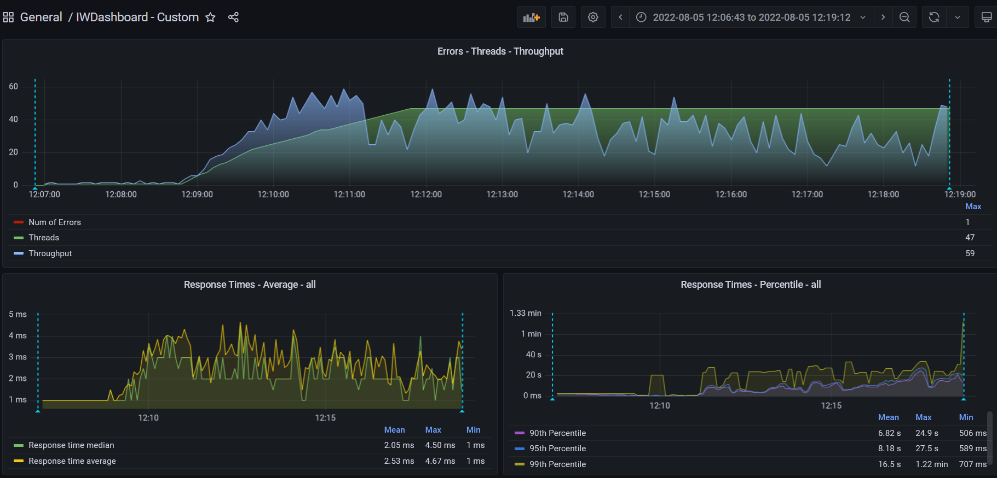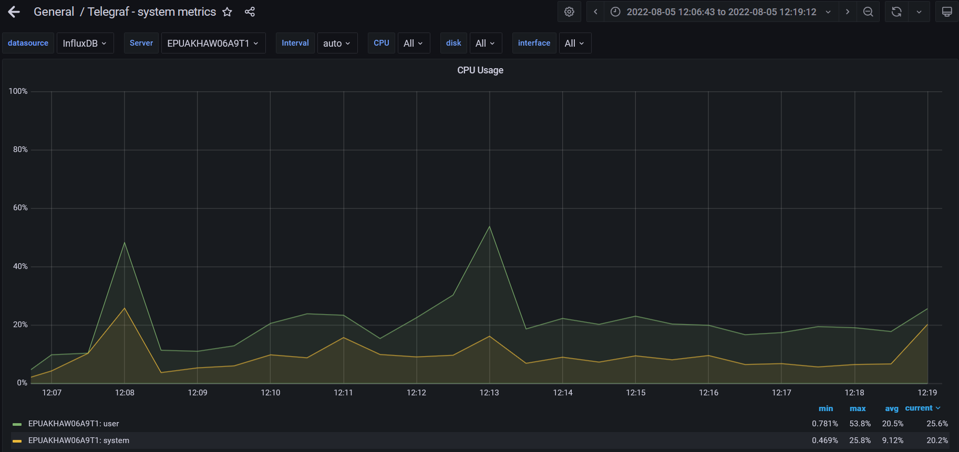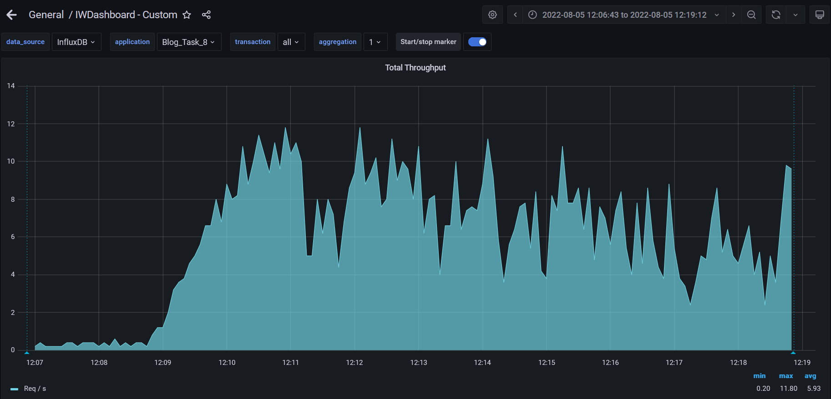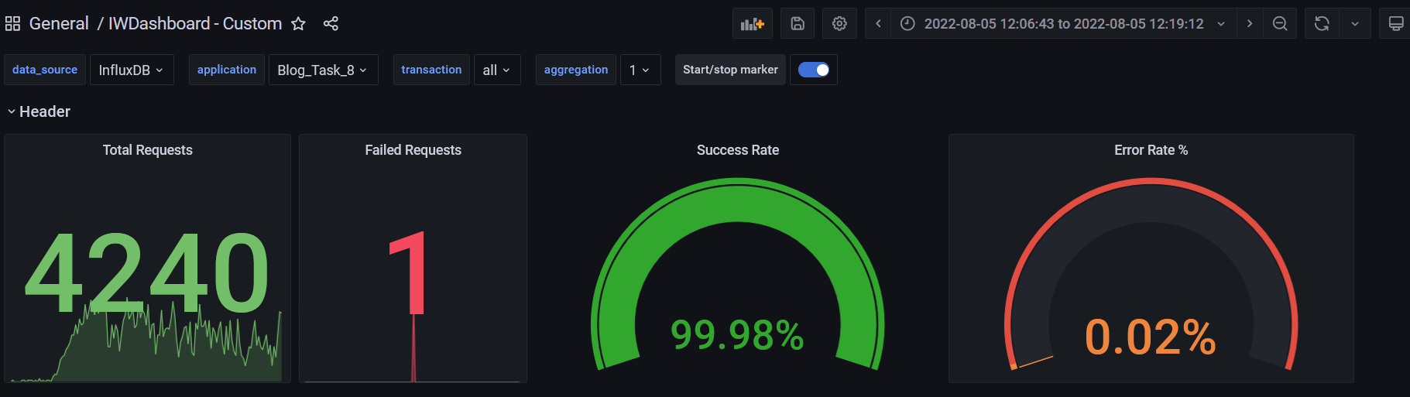

**Test Run #3**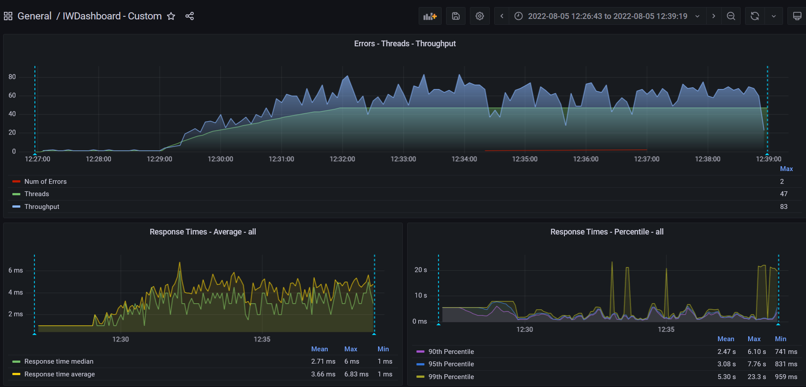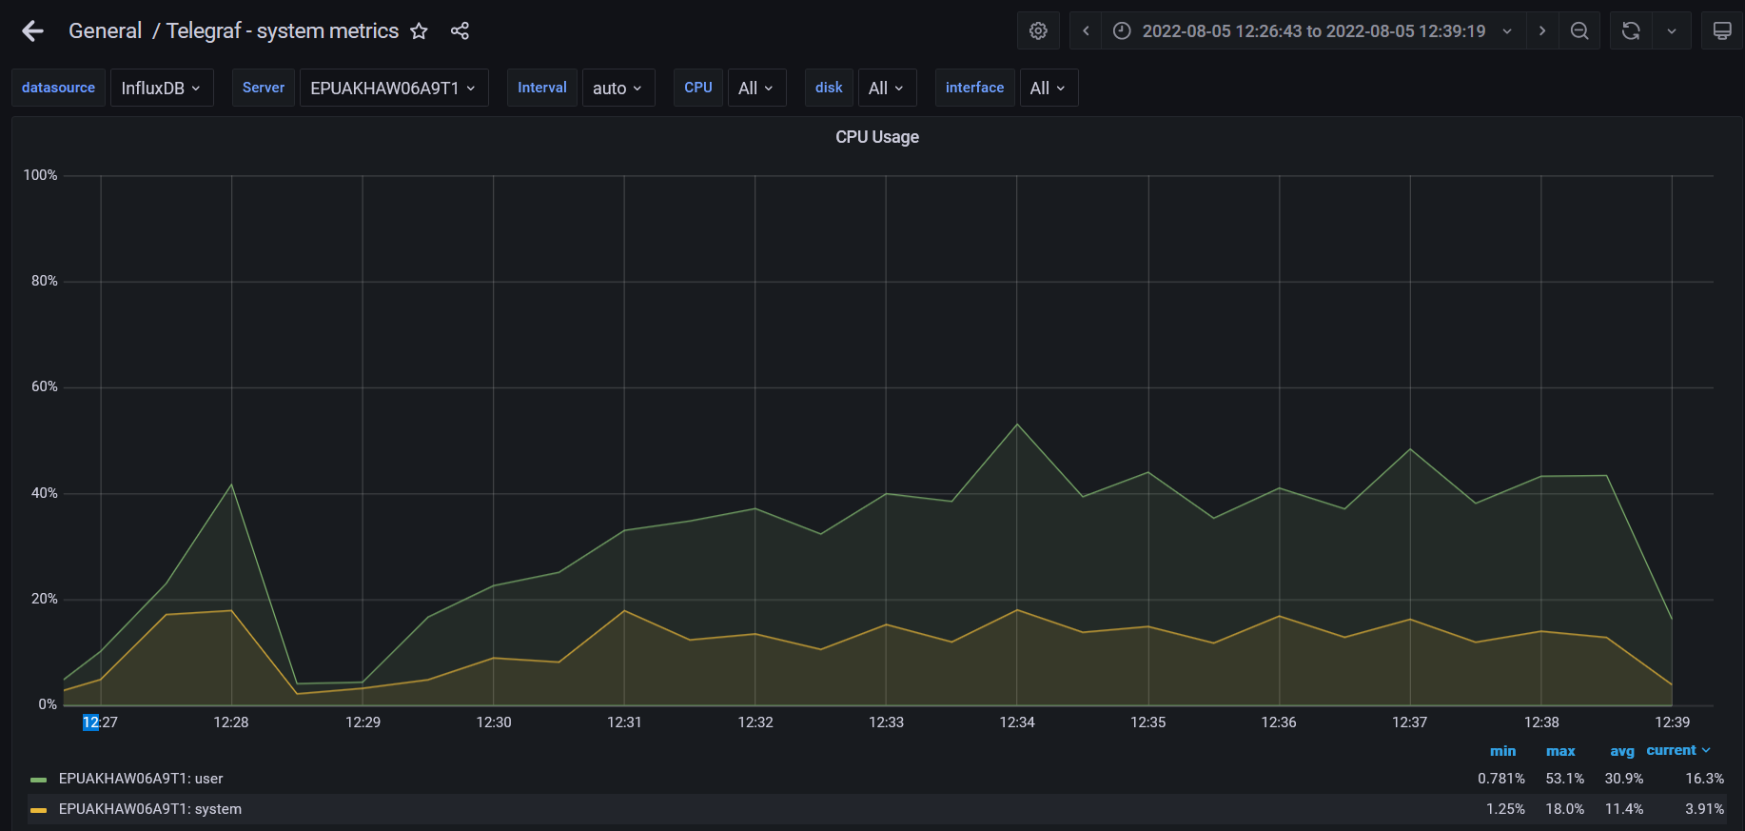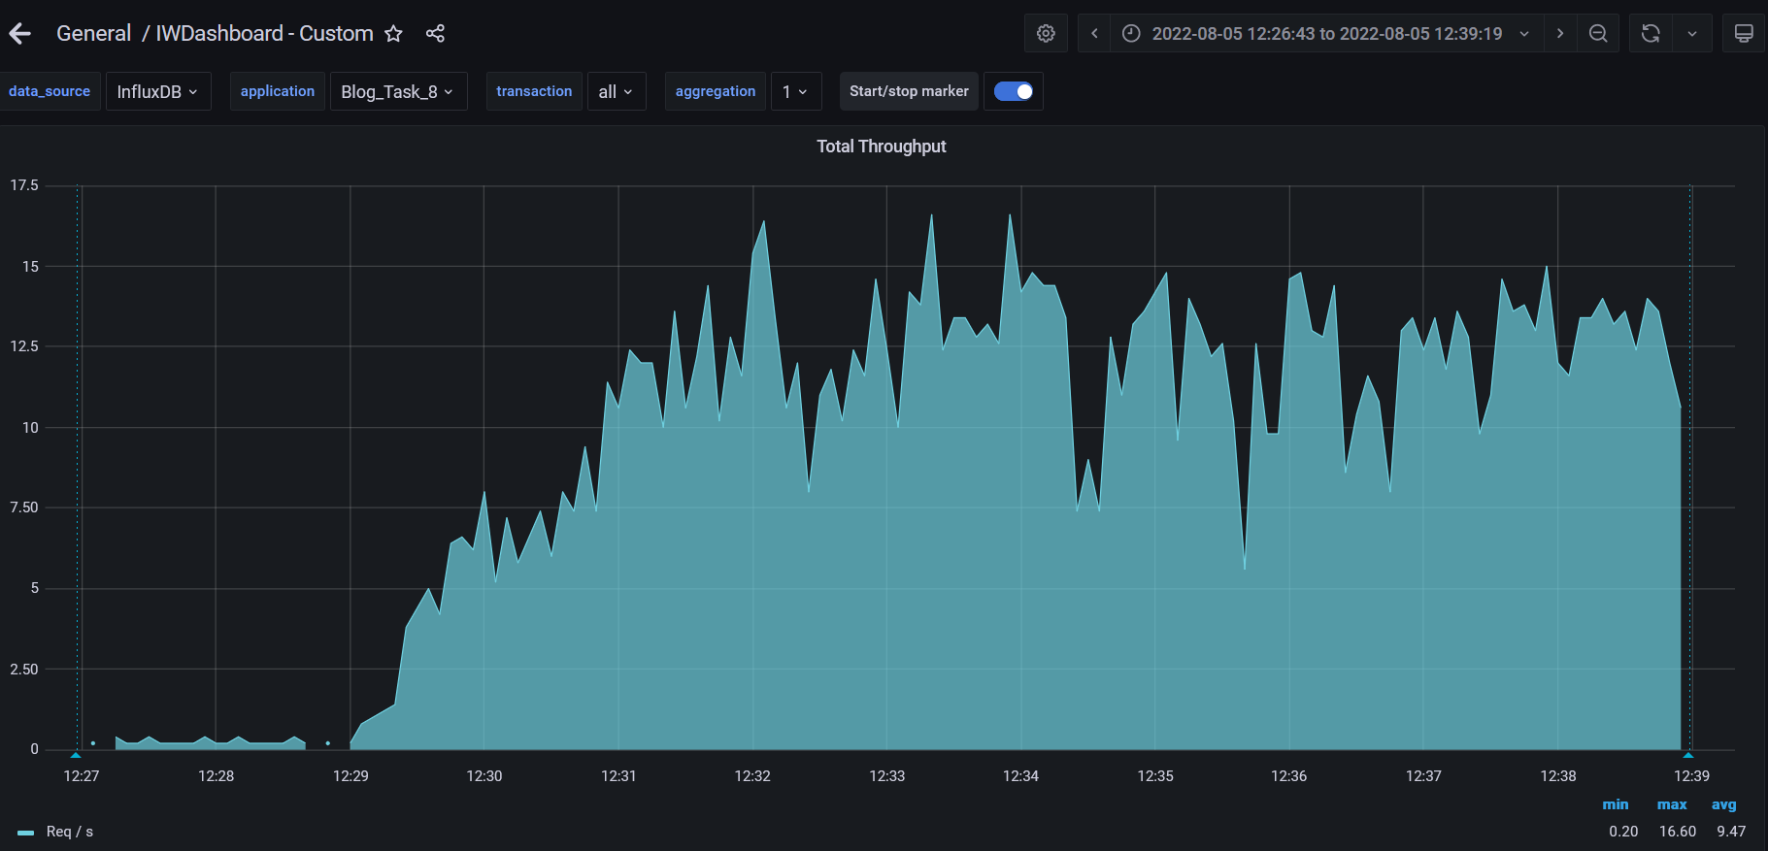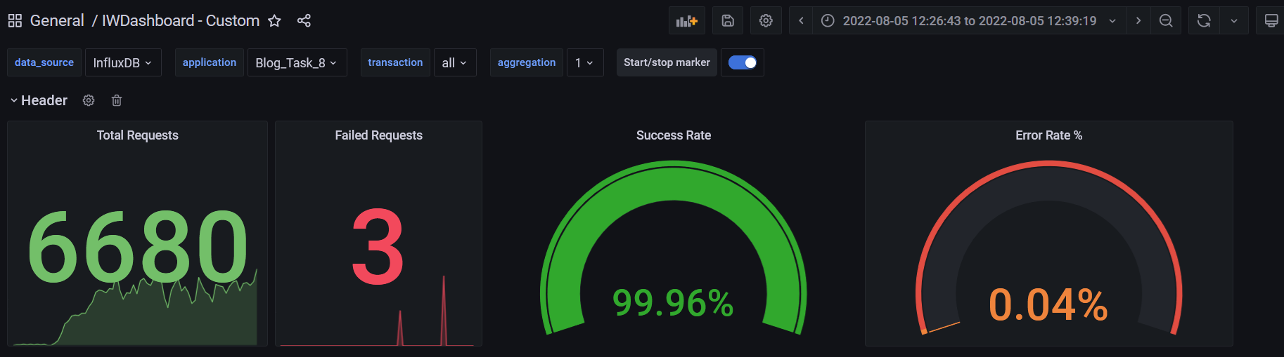

**Test Run #4**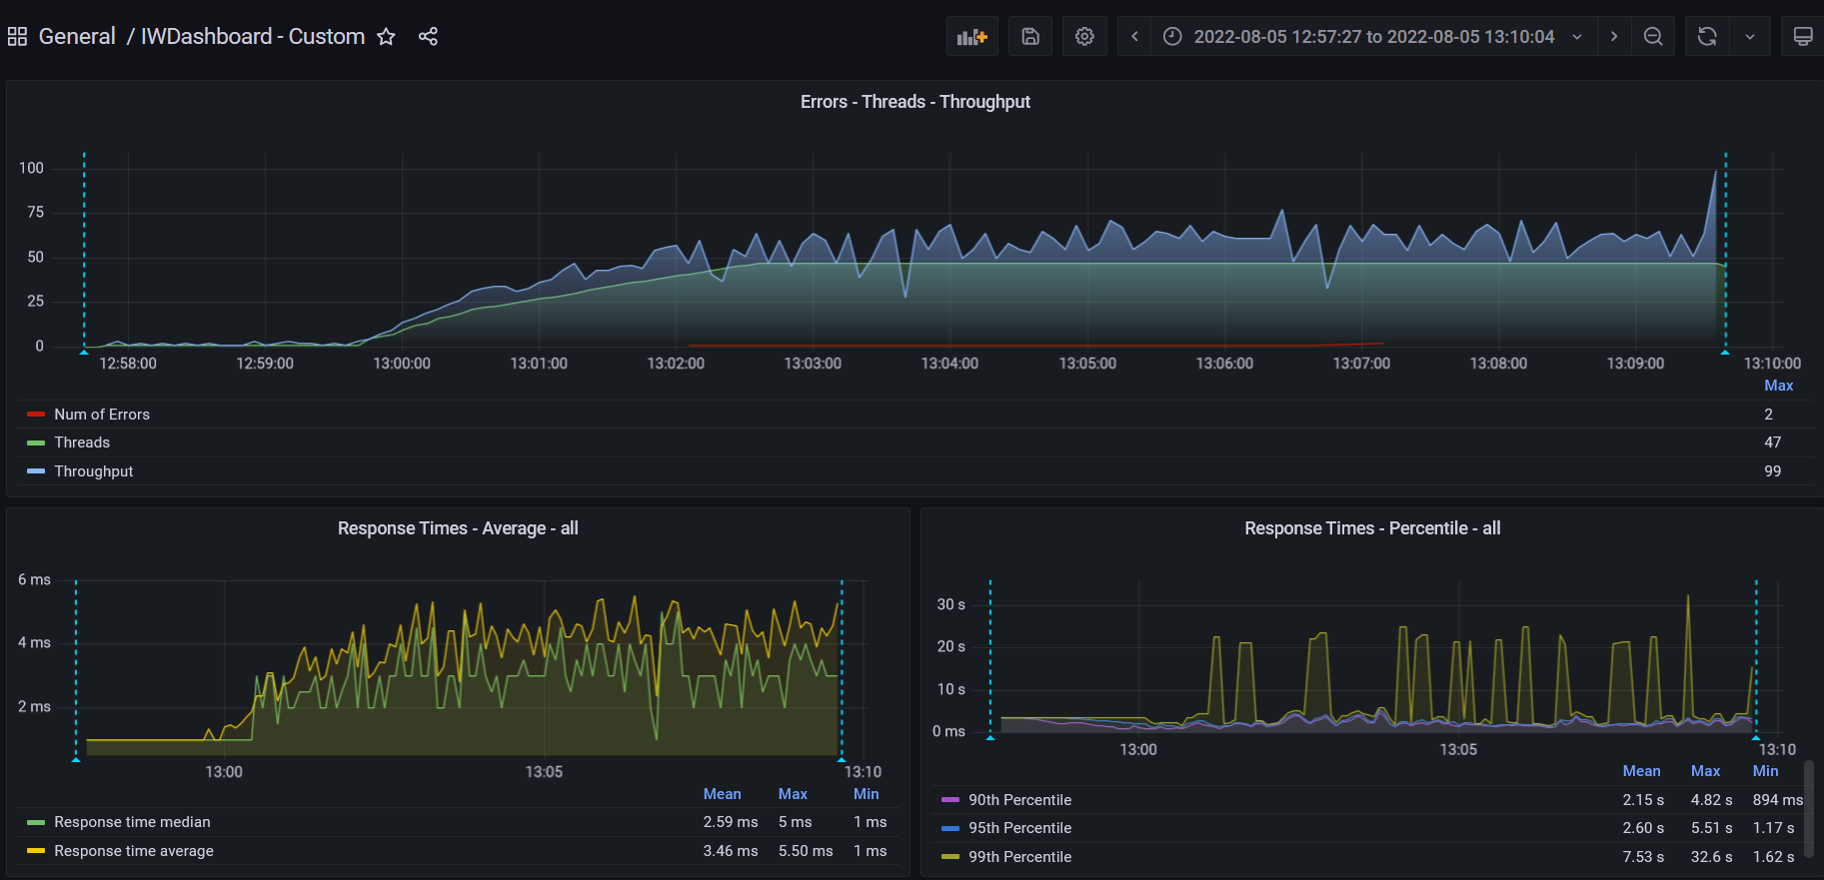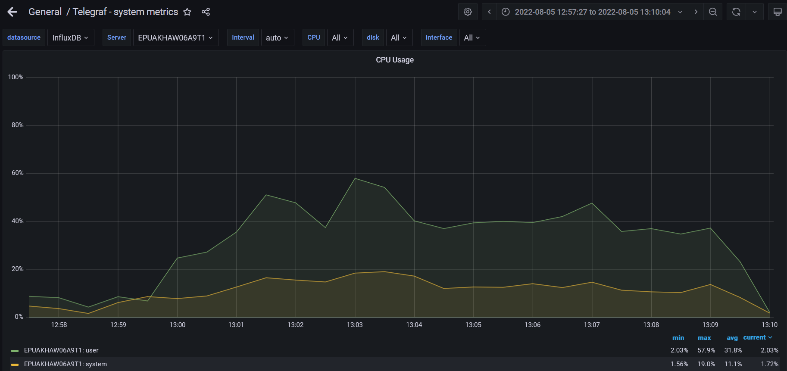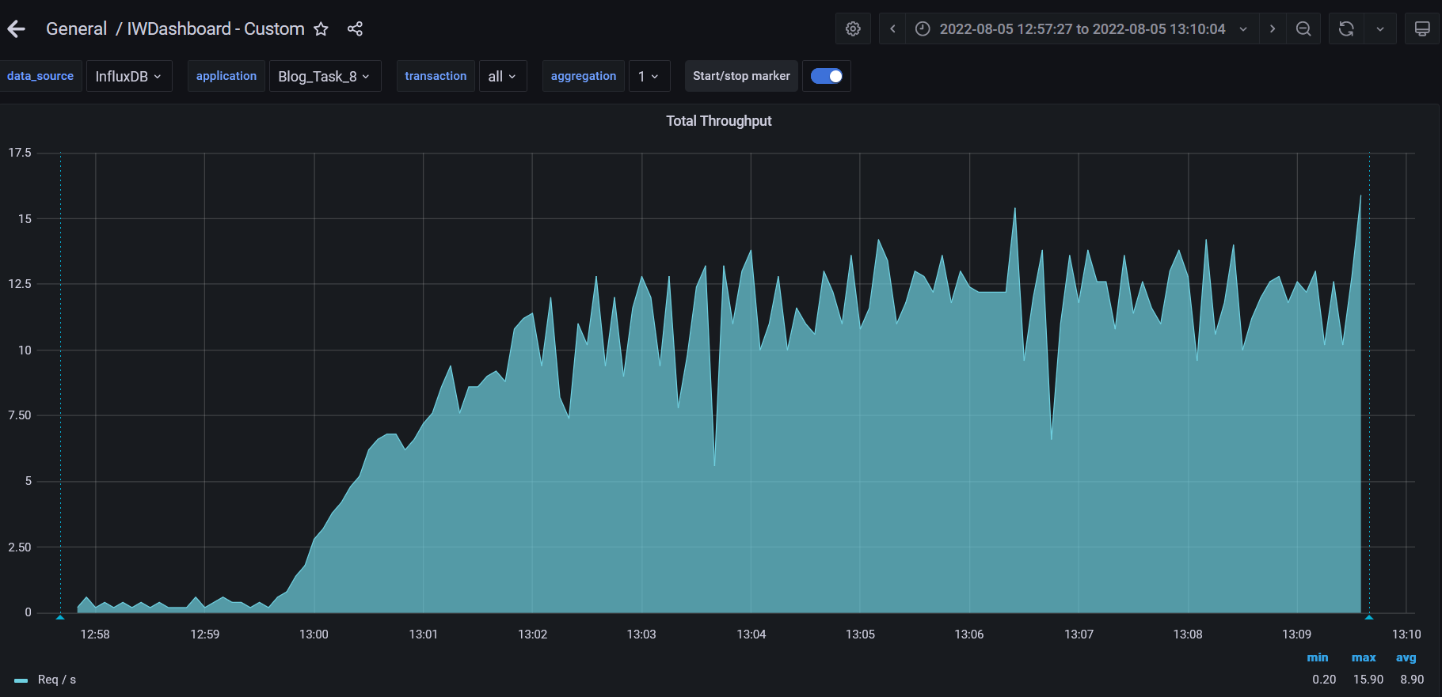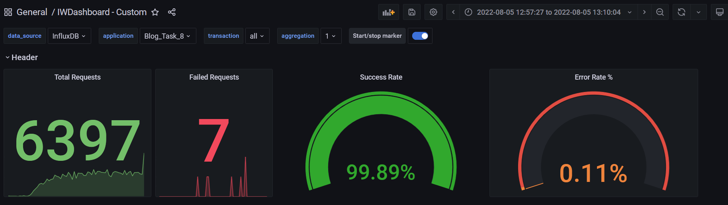

**Test Run #5**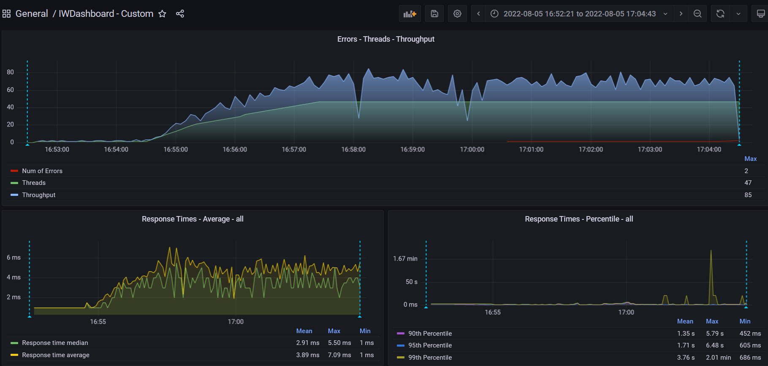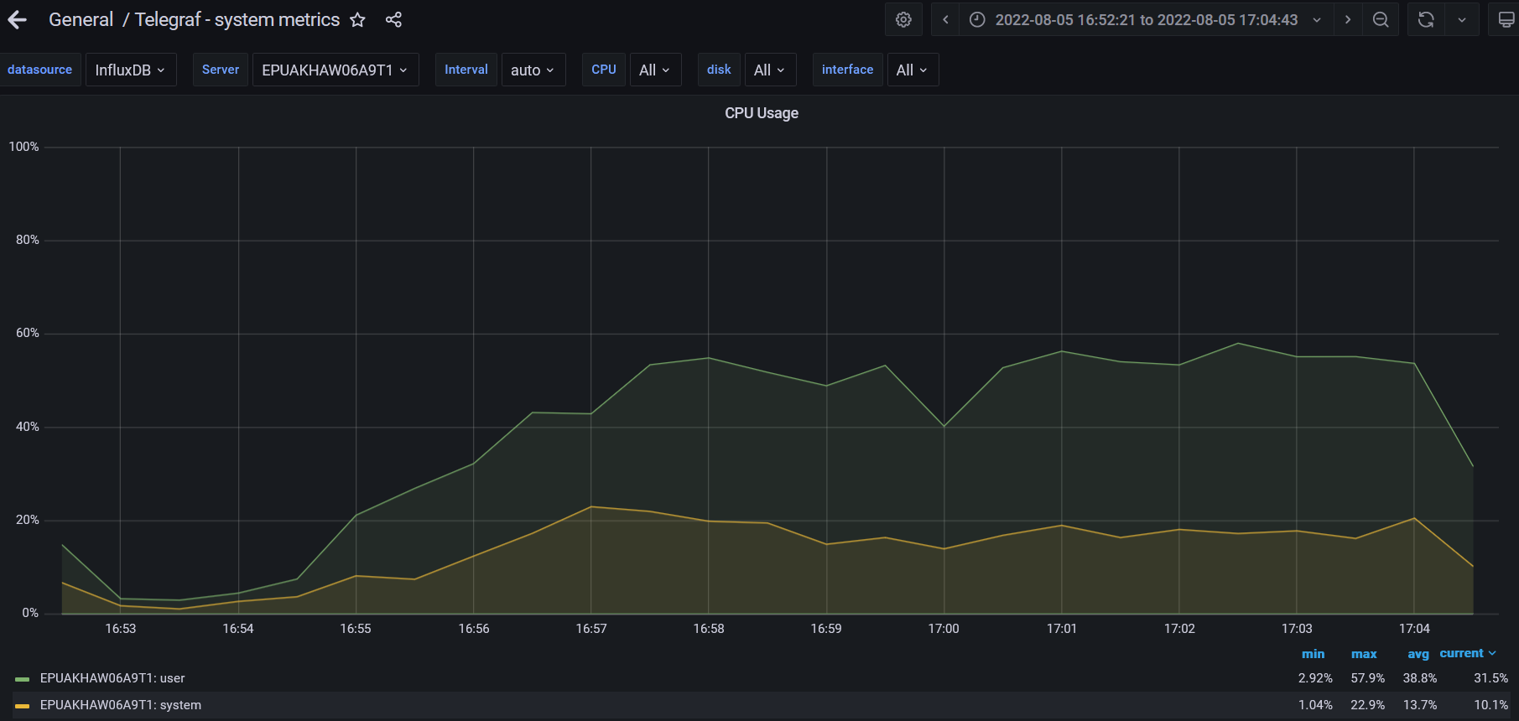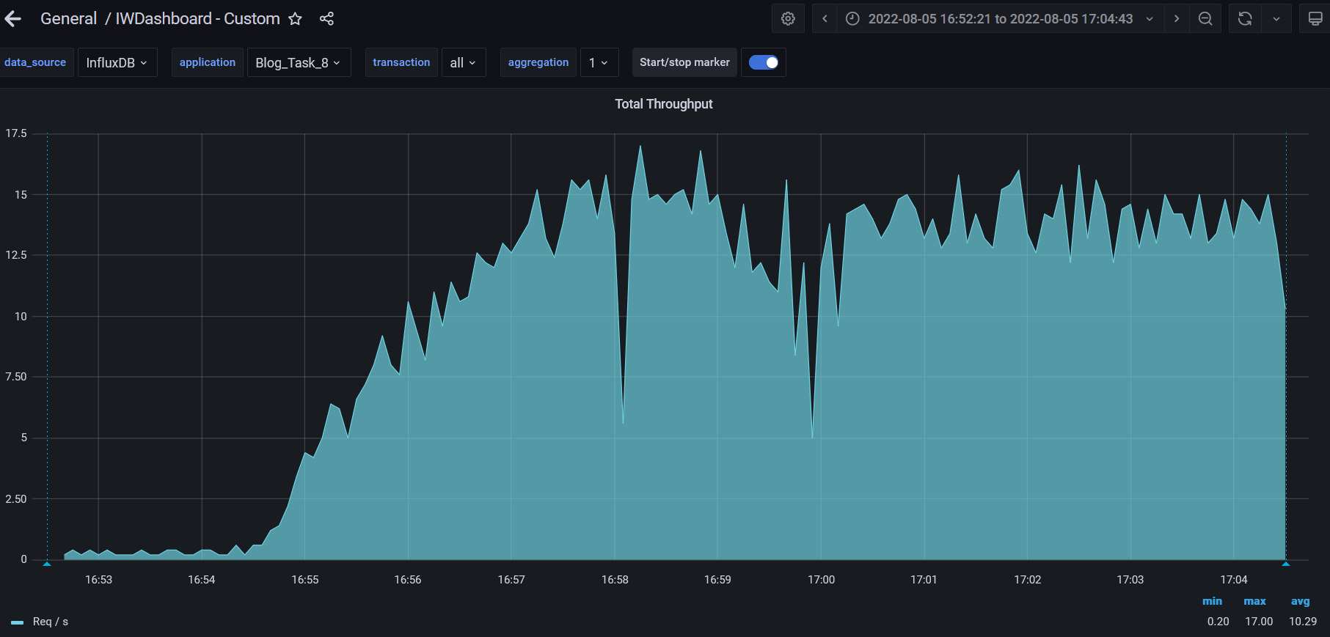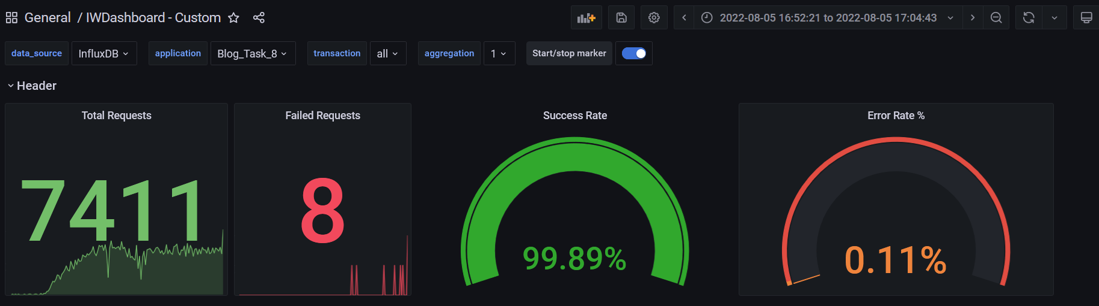

**Test Run #6**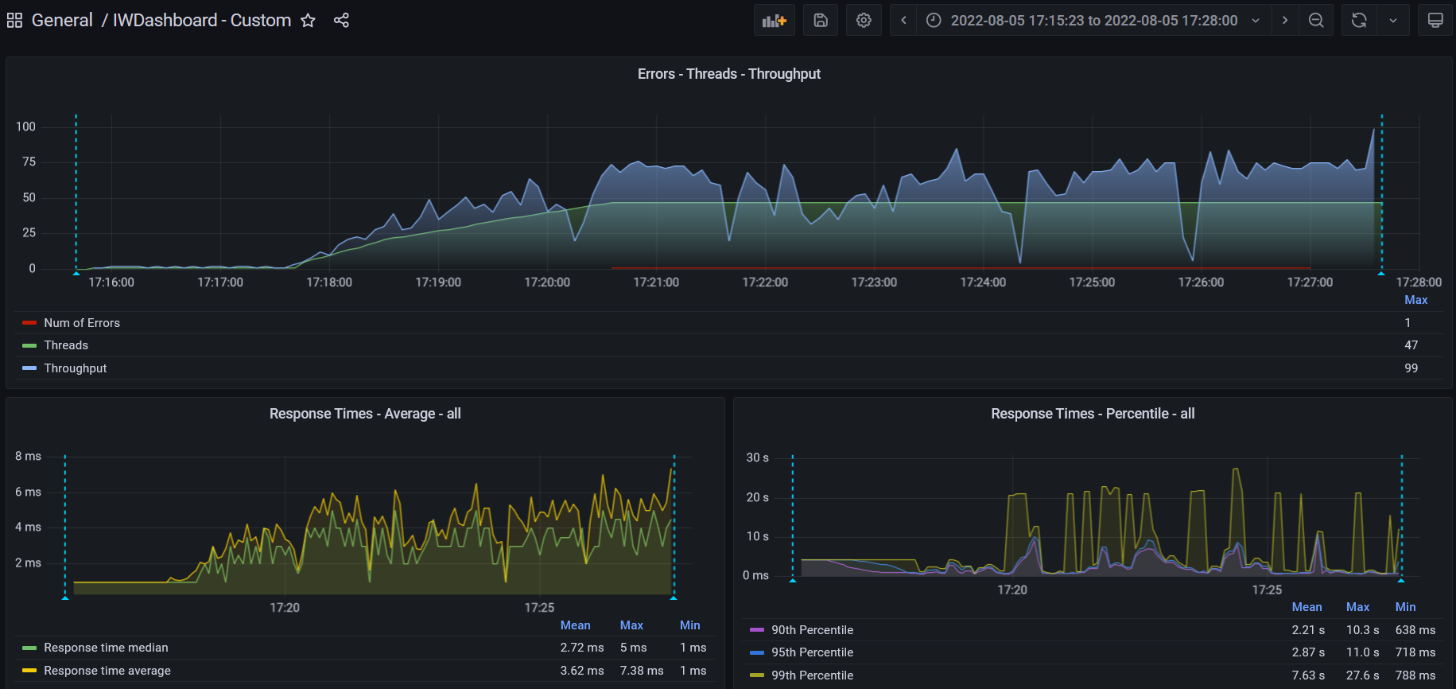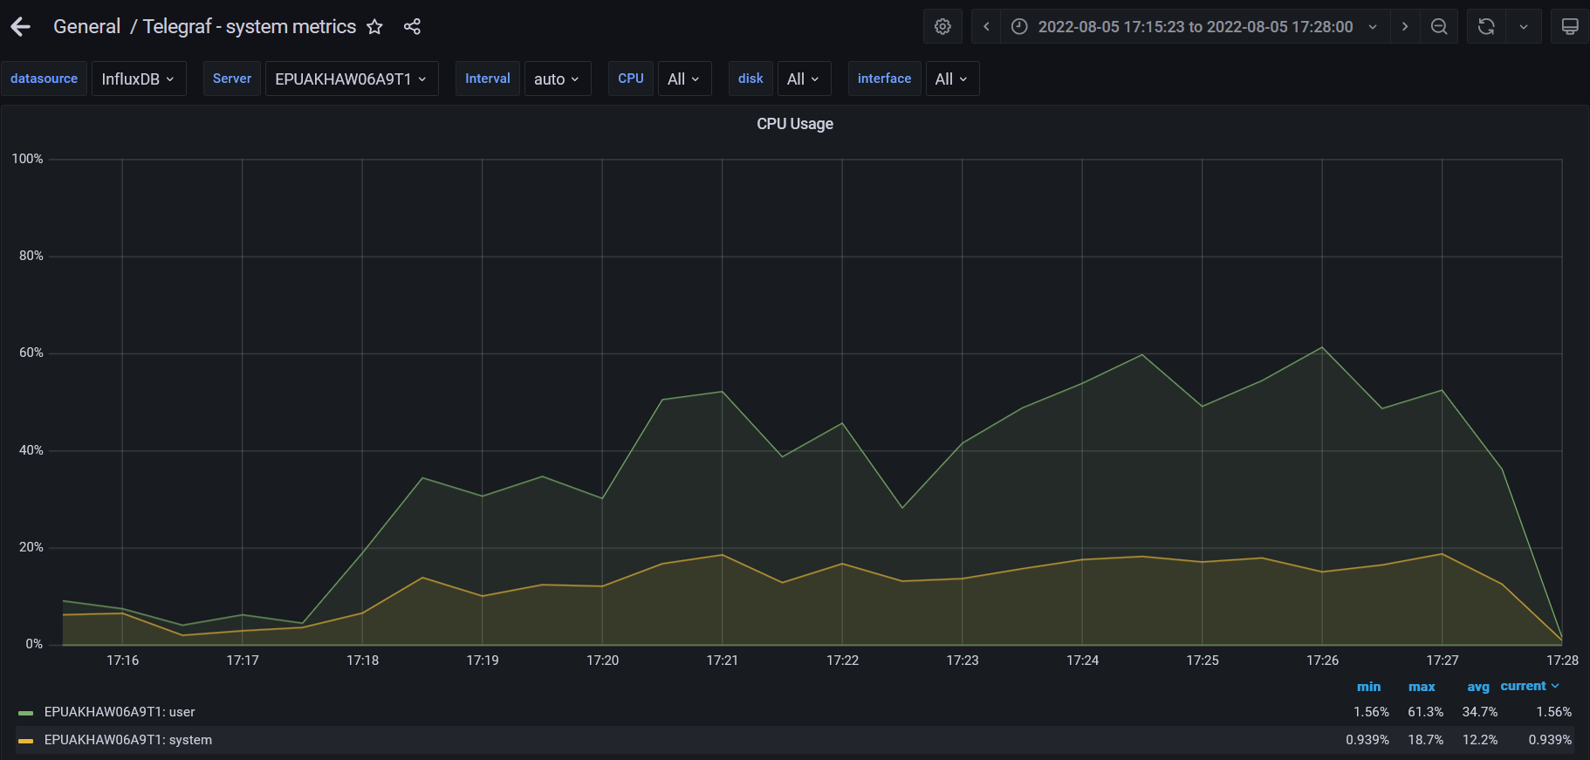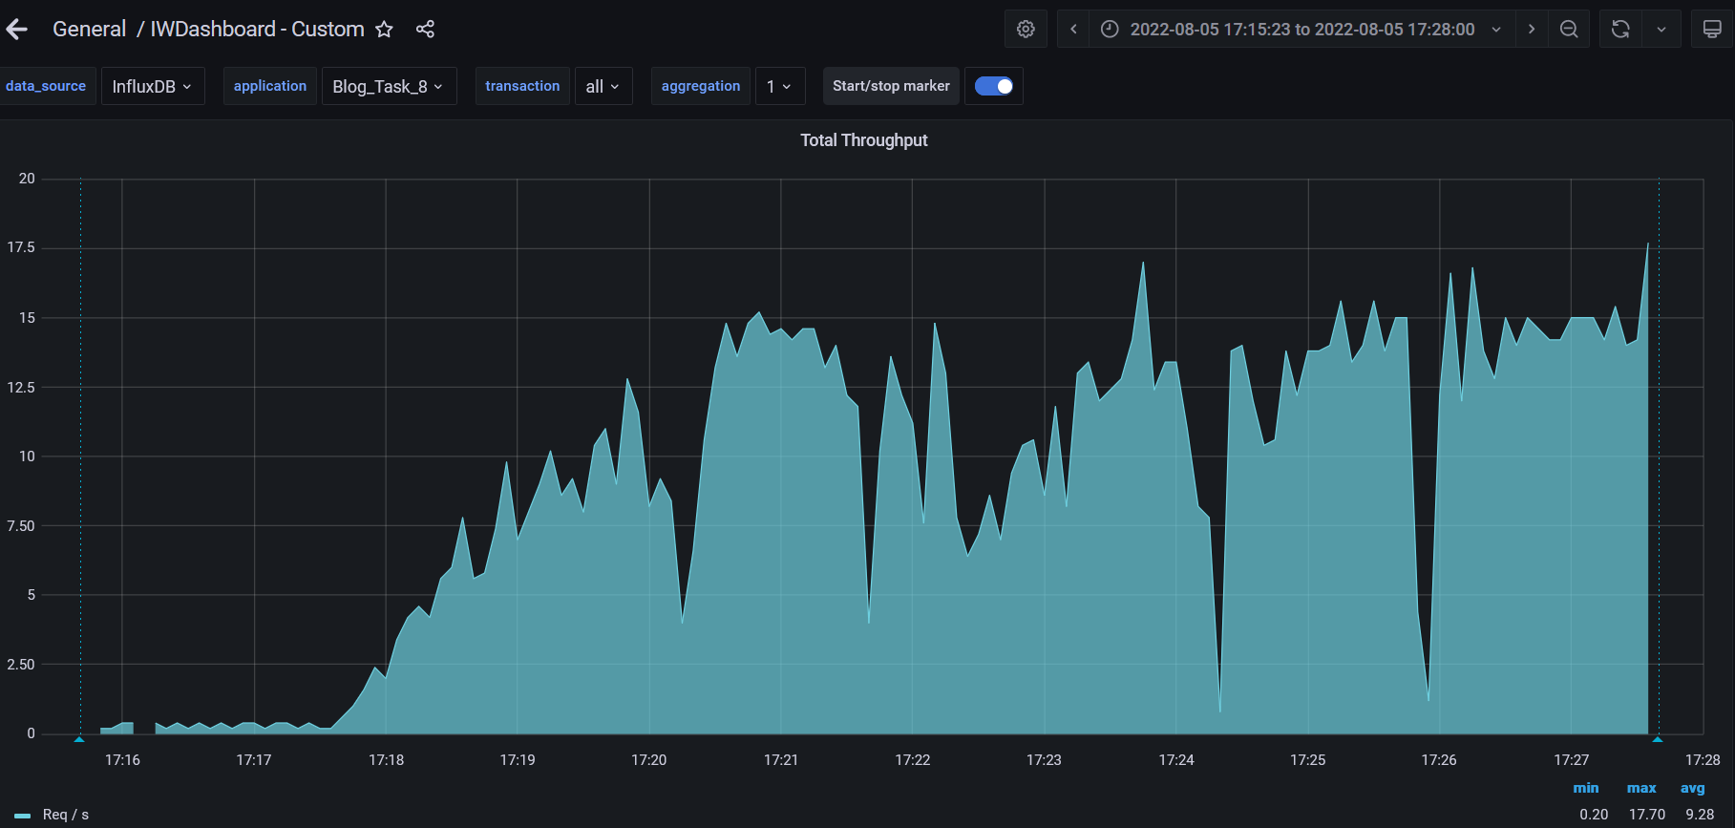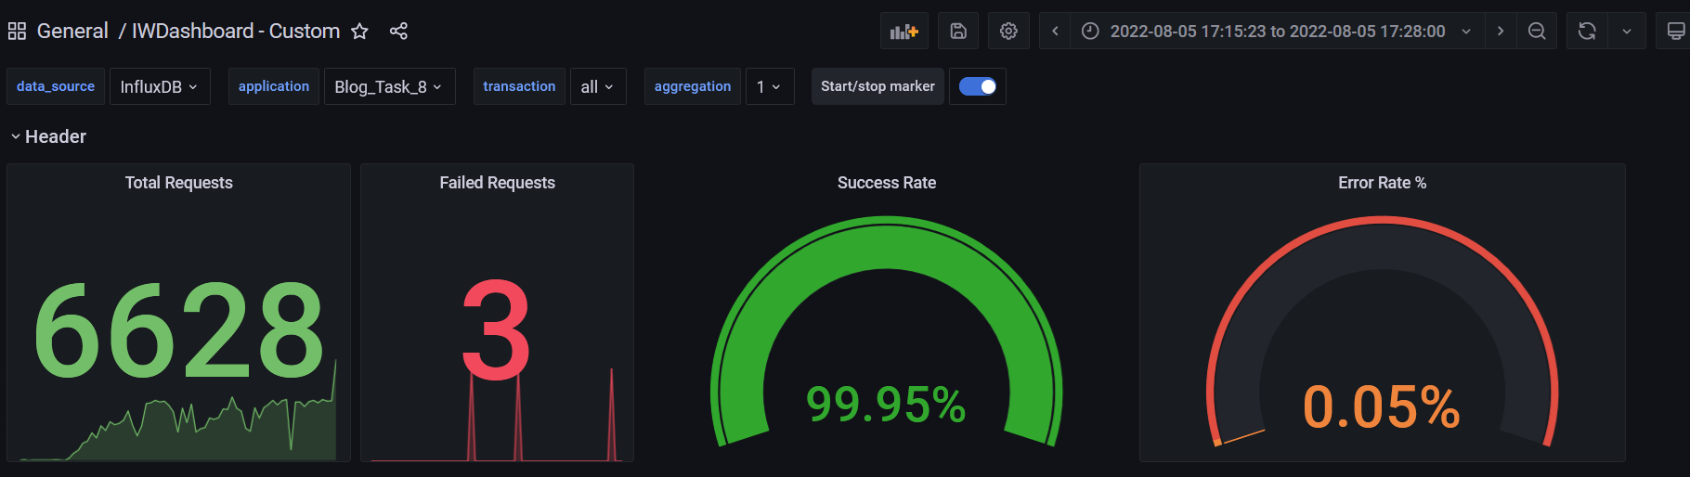

**Test Run #7**

**Detailed error report**

|  |  |  |
| --- | --- | --- |
| Response Code | Transaction | Error count |
| 500 | |  | | --- | | Transaction Controller (Open Large Calendar) | | Transaction Controller (Open PredefineDate) | | Transaction Controller (Save Post) | | Transaction Controller (Search By Name) | | 1  3  18  2 |
| 400 | Transaction Controller (Open Home Page Anonymous)  Transaction Controller (Open PredefineDate)  Transaction Controller (Open RandomDate)  Transaction Controller (Search By Name) | 2  9  2  3 |

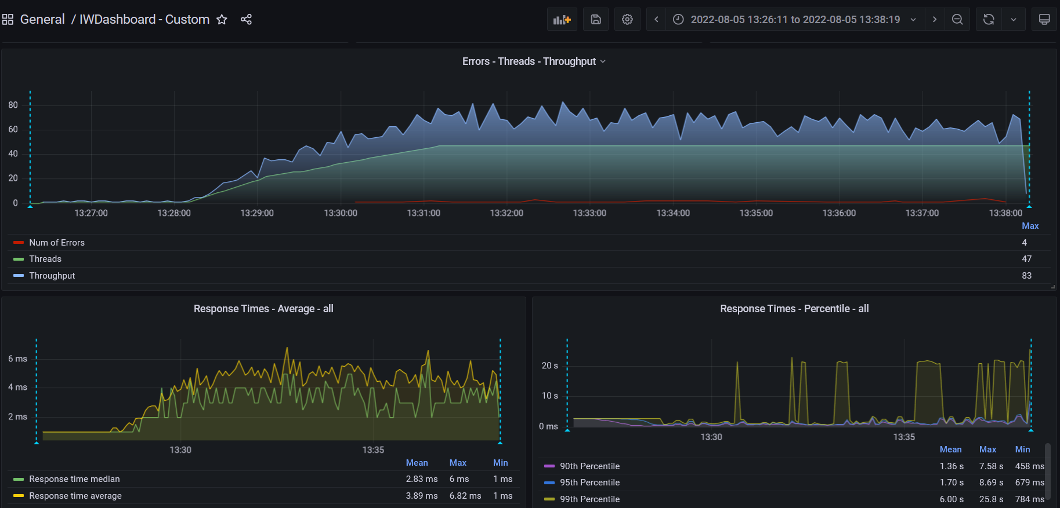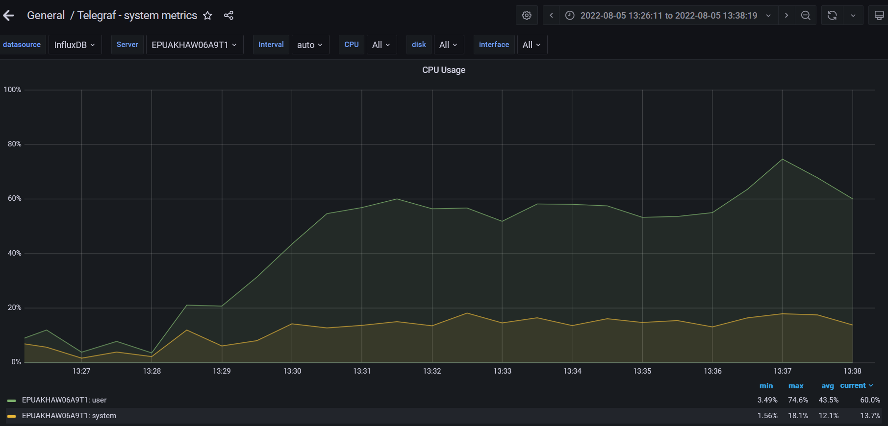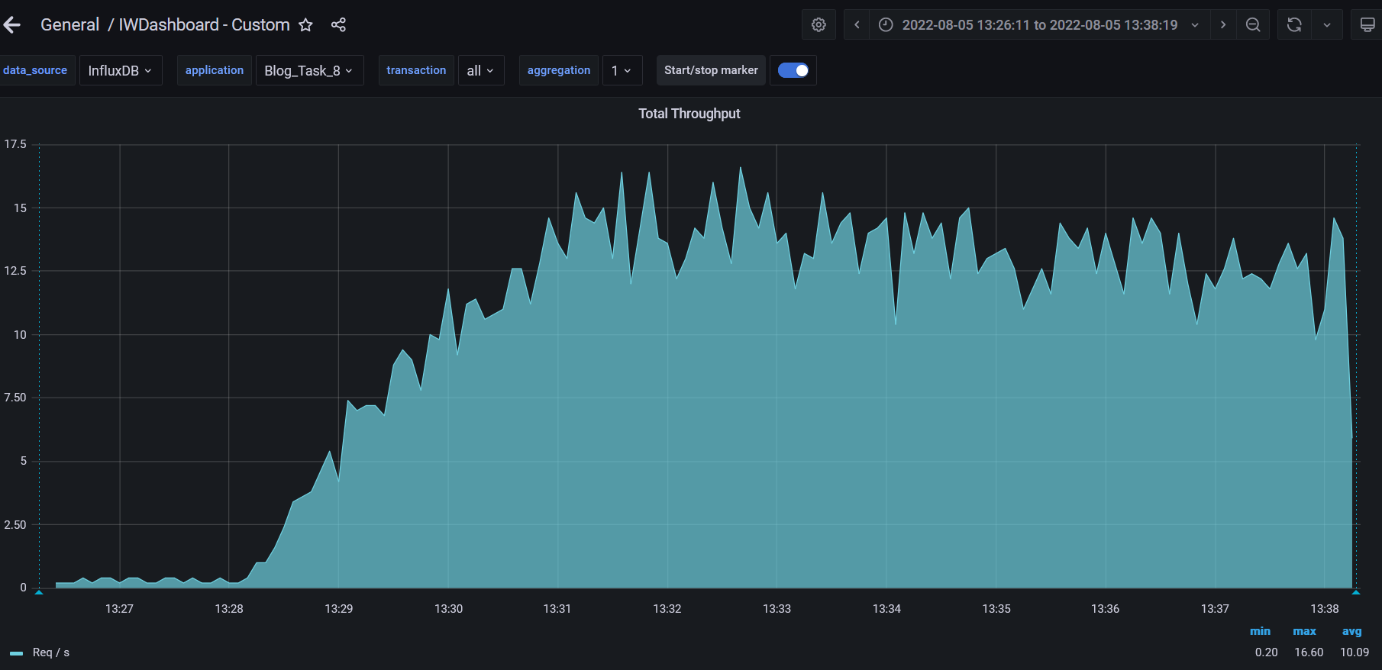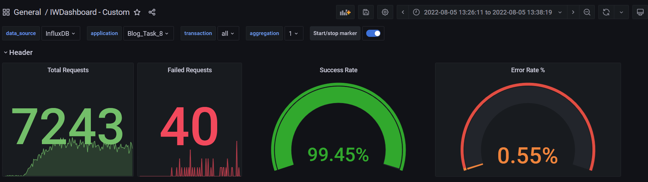

**Test Run #8**

**Detailed error report**

|  |  |  |
| --- | --- | --- |
| Response Code | Transaction | Error count |
| 500 | Transaction Controller (Open PredefineDate)  Transaction Controller (Save Post) | 1  19 |
| 400 | Transaction Controller (Open Home Page Anonymous)  Transaction Controller (Open PredefineDate)  Transaction Controller (Open RandomDate)  Transaction Controller (Search By Name) | 1  1  1  5 |

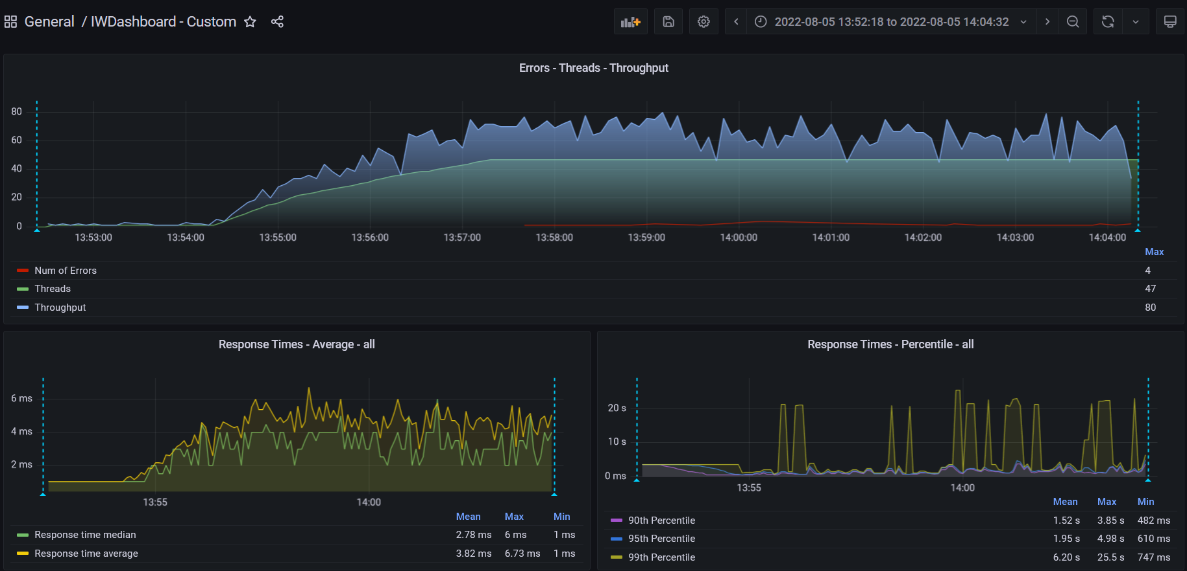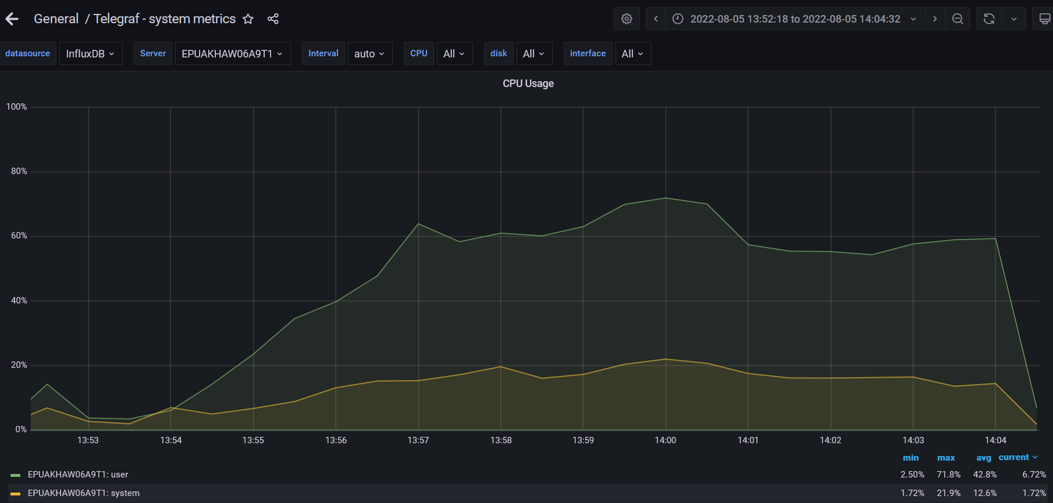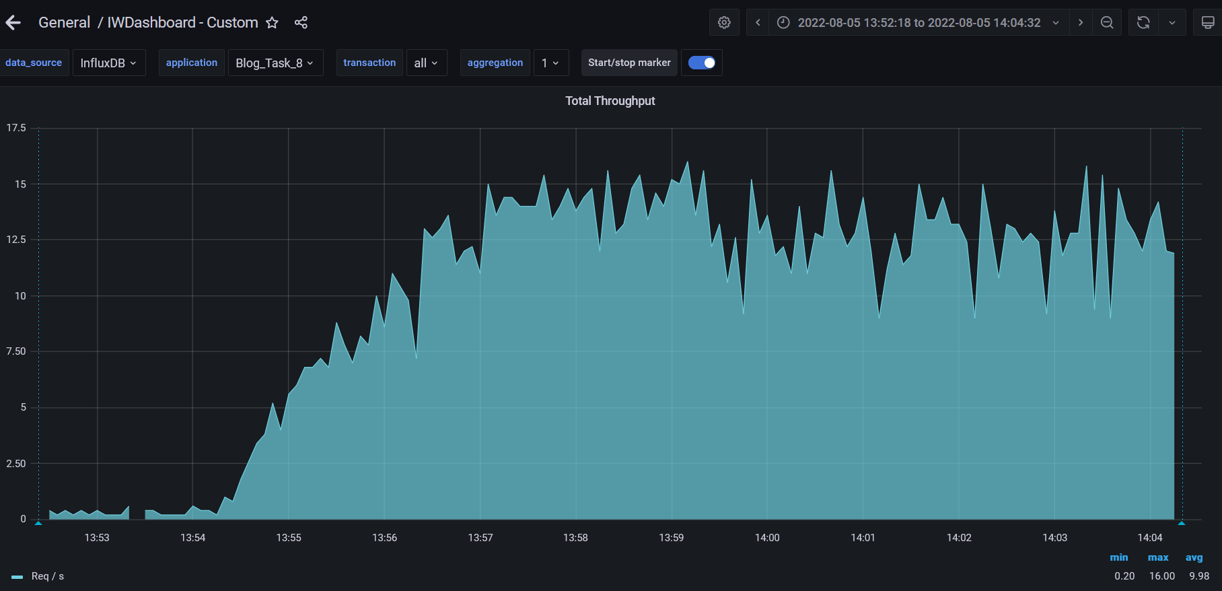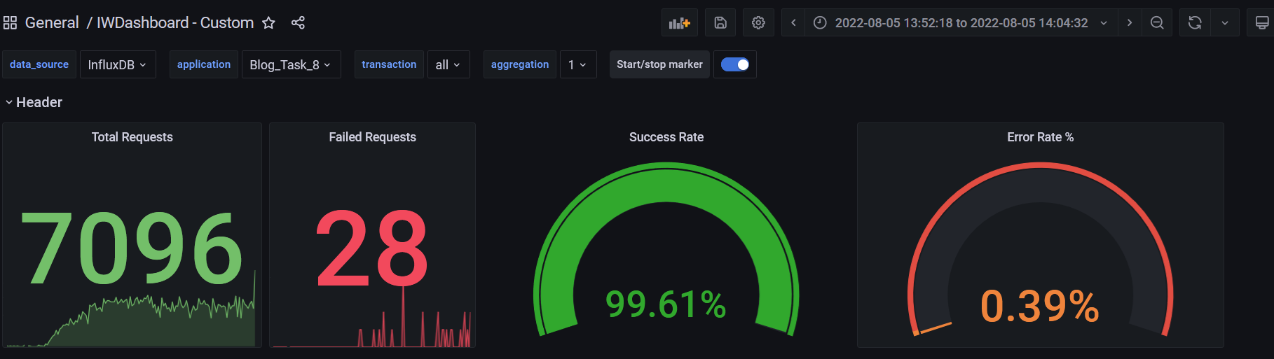

**Test Run #9**

**Detailed error report**

|  |  |  |
| --- | --- | --- |
| Response Code | Transaction | Error count |
| 500 | Transaction Controller (Open Home Page Anonymous)  Transaction Controller (Open Large Calendar)  Transaction Controller (Open PredefineDate)  Transaction Controller (Open RandomDate)  Transaction Controller (Save Post) | 2  1  2  1  13 |
| 400 | Transaction Controller (Open Home Page Anonymous)  Transaction Controller (Open PredefineDate)  Transaction Controller (Open RandomDate)  Transaction Controller (Search By Name) | 2  5  2  5 |

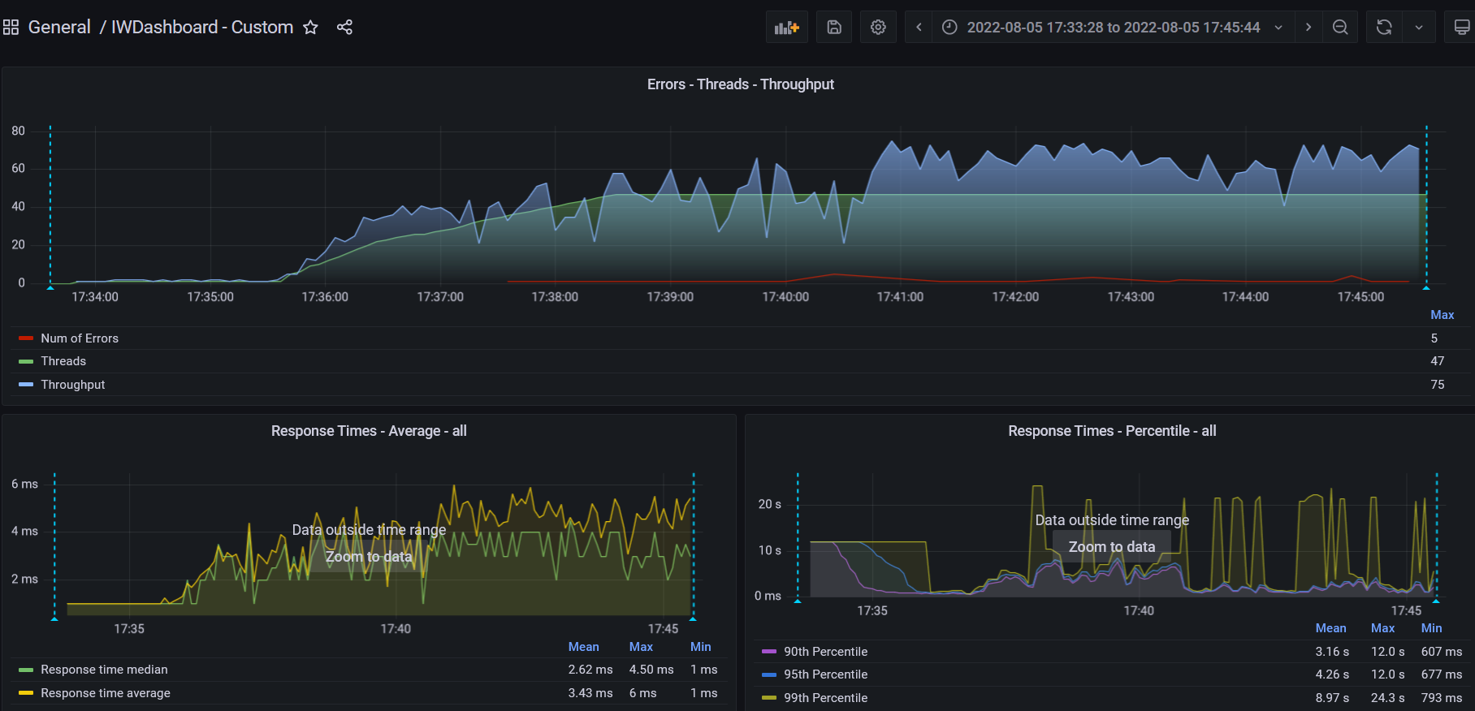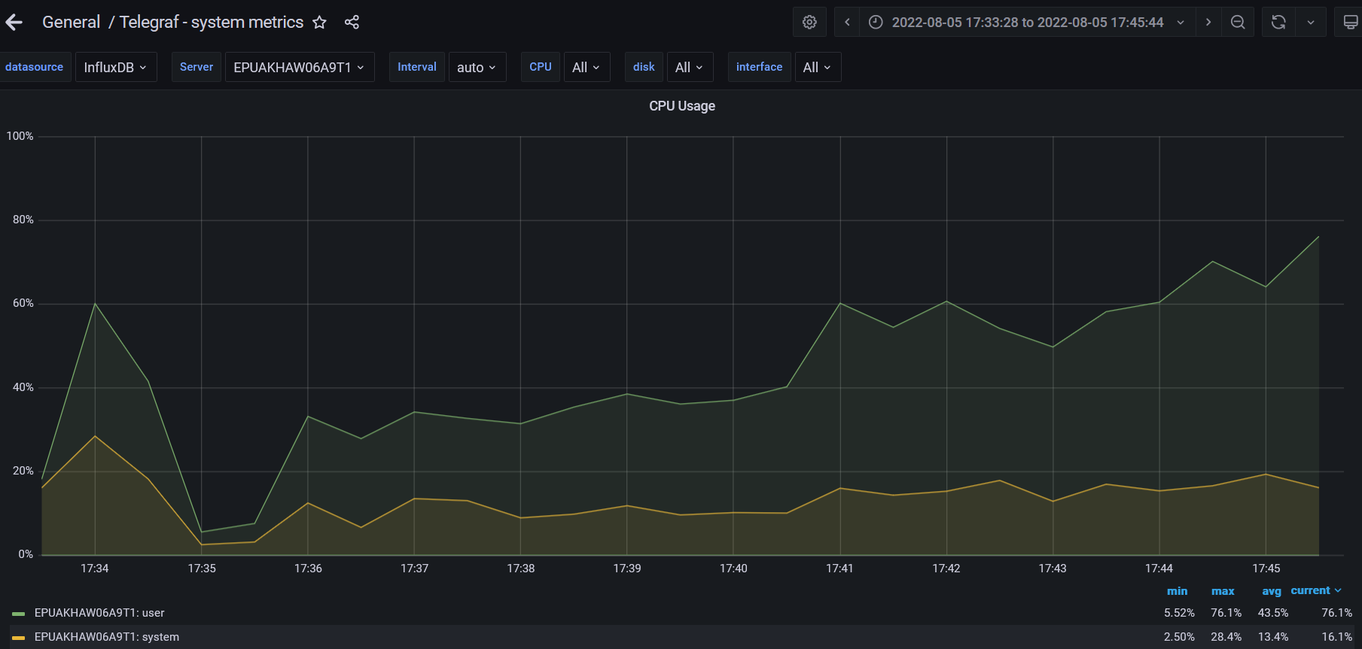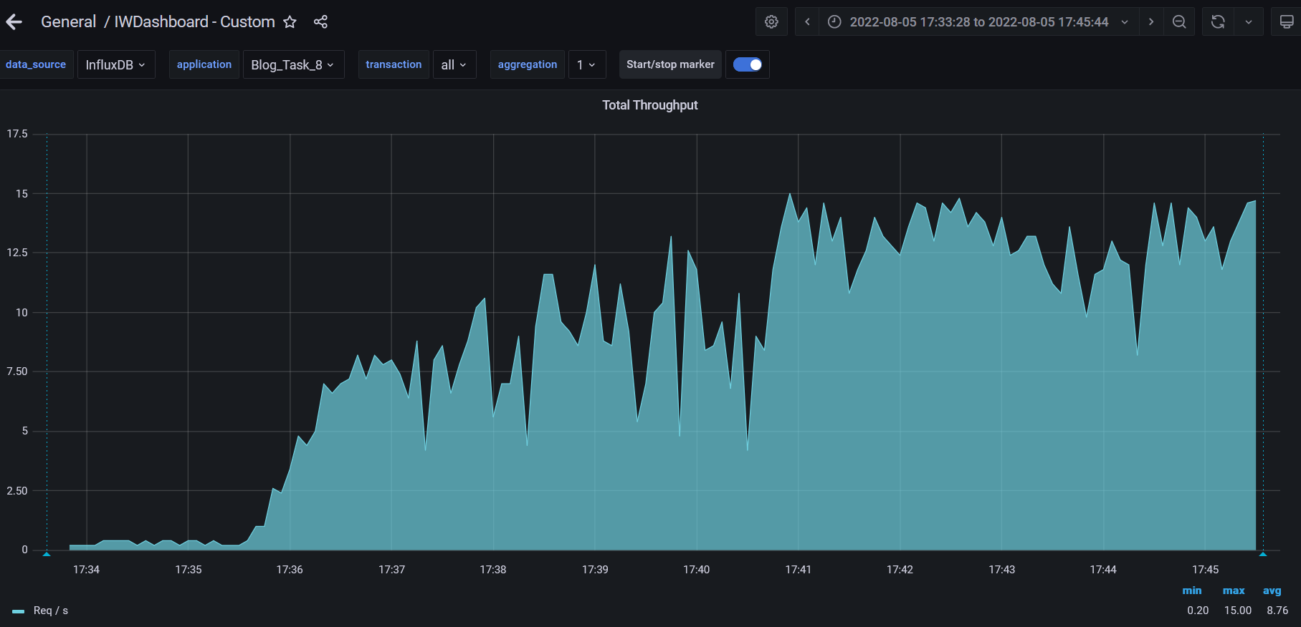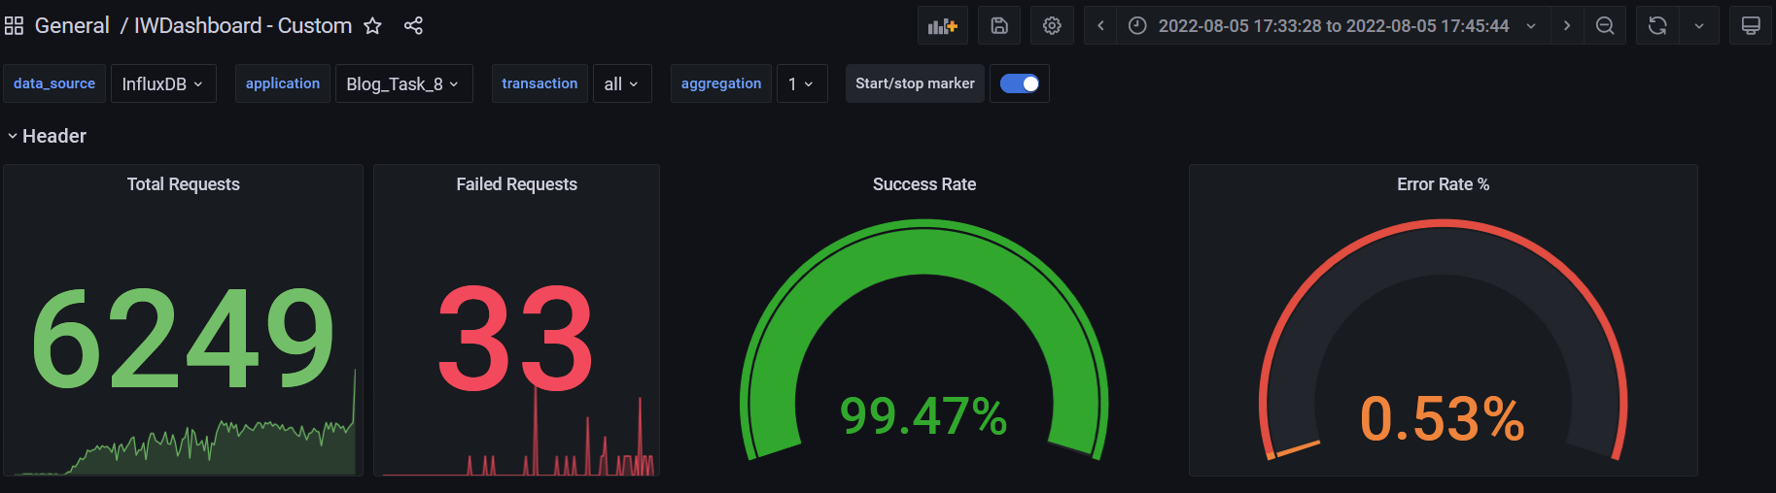

**Test Run #10**

**Detailed error report**

|  |  |  |
| --- | --- | --- |
| Response Code | Transaction | Error count |
| 500 | Transaction Controller (Add User)  Transaction Controller (Open PredefineDate)  Transaction Controller (Open RandomDate)  Transaction Controller (Save Post) | 1  1  2  20 |
| 400 | Transaction Controller (Open Home Page Anonymous)  Transaction Controller (Open PredefineDate)  Transaction Controller (Open RandomDate)  Transaction Controller (Search By Name) | 1  5  3  4 |

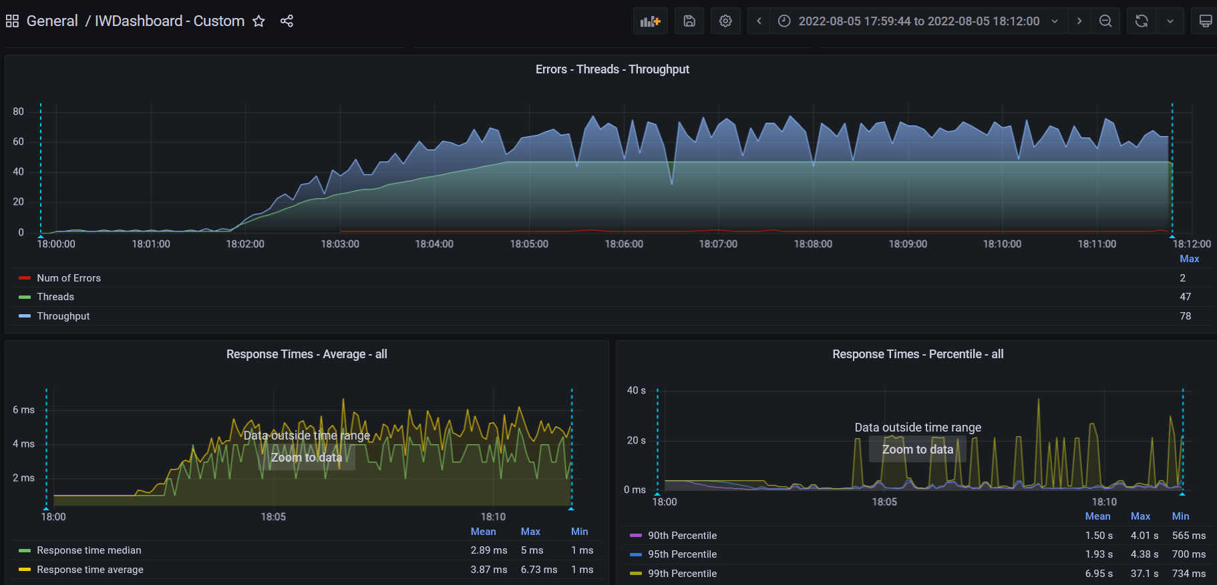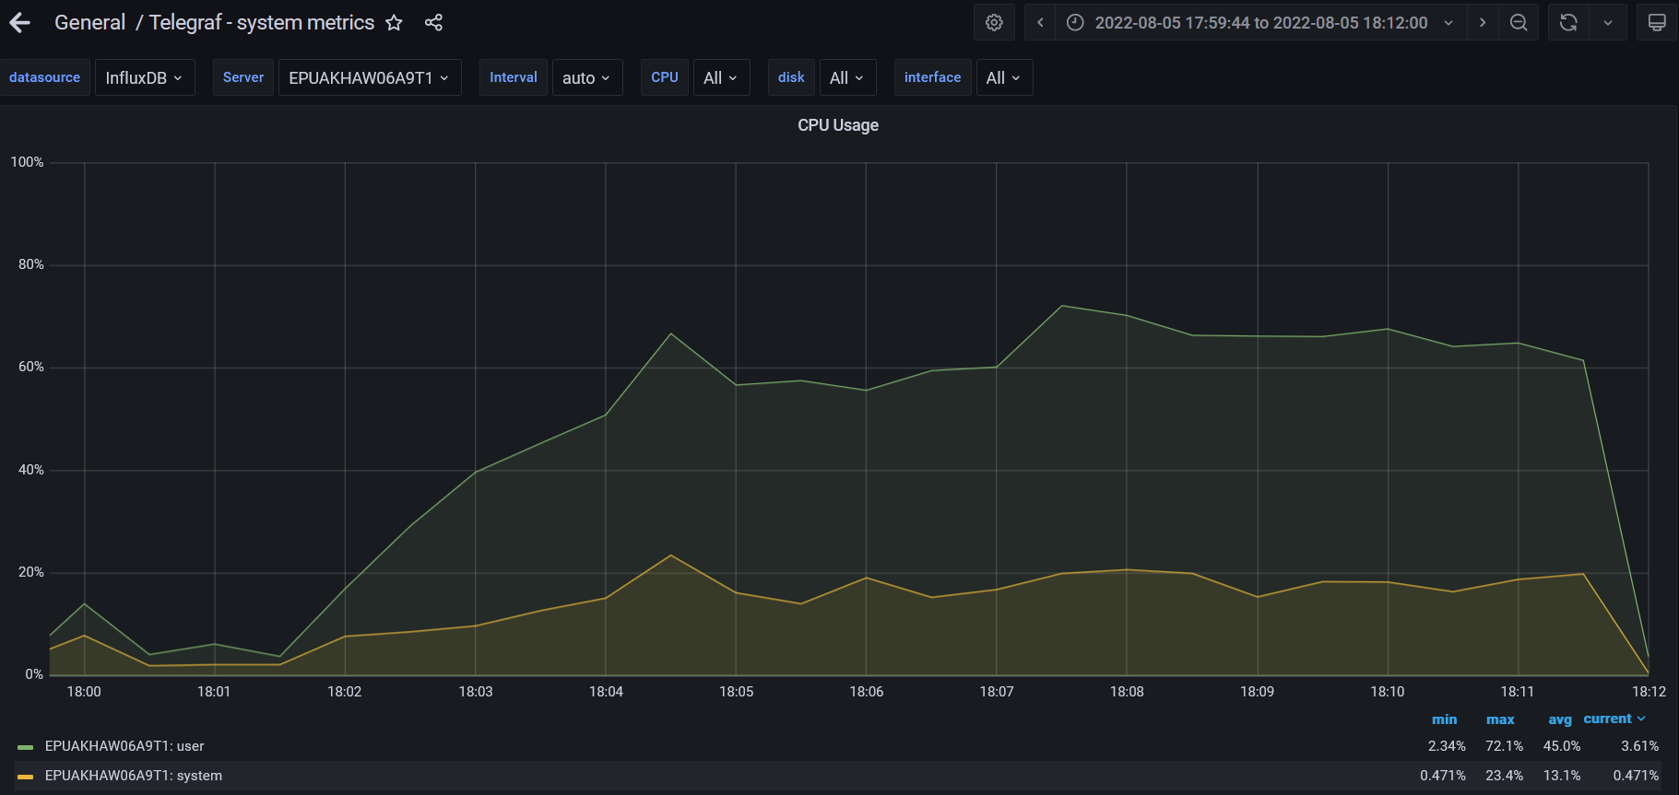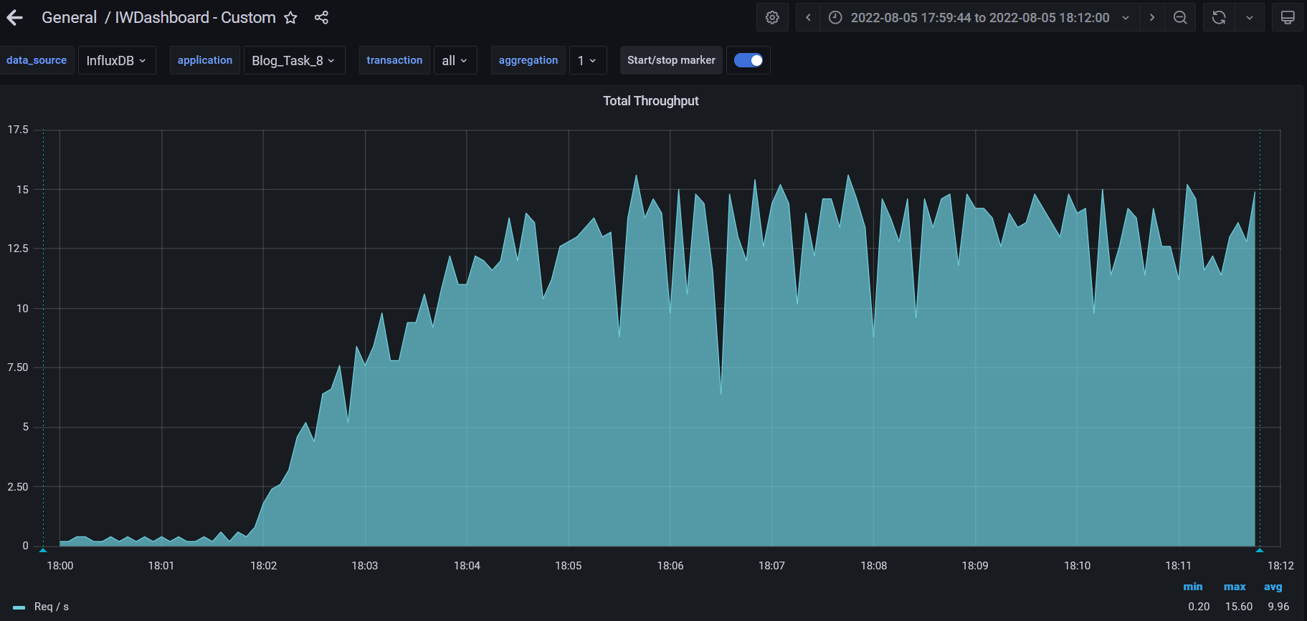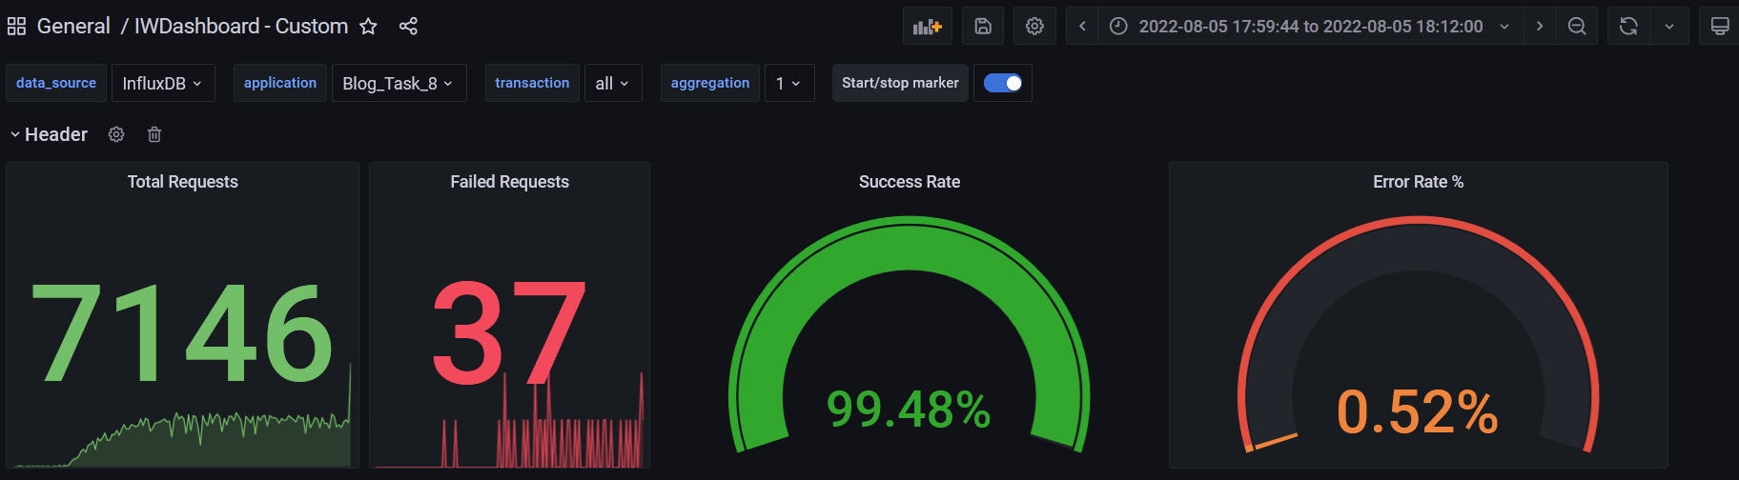

**Test Run #11**

**Detailed error report**

|  |  |  |
| --- | --- | --- |
| Response Code | Transaction | Error count |
| 500 | Transaction Controller (Open Contacts)  Transaction Controller (Open Date)  Transaction Controller (Open Home Page Anonymous)  Transaction Controller (Open Home Page)  Transaction Controller (Open Large Calendar)  Transaction Controller (Open Post)  Transaction Controller (Open PredefineDate)  Transaction Controller (Open RandomDate)  Transaction Controller (Save Post)  Transaction Controller (Search By Name) | 2  8  10  1  13  2  25  11  78  18 |
| 400 | Transaction Controller (Open Home Page Anonymous)  Transaction Controller (Open Post)  Transaction Controller (Open PredefineDate)  Transaction Controller (Open RandomDate)  Transaction Controller (Search By Name) | 14  8  49  12  30 |
| Non HTTP response code: java.net.URISyntaxException | Transaction Controller (Edit Post) | 10 |

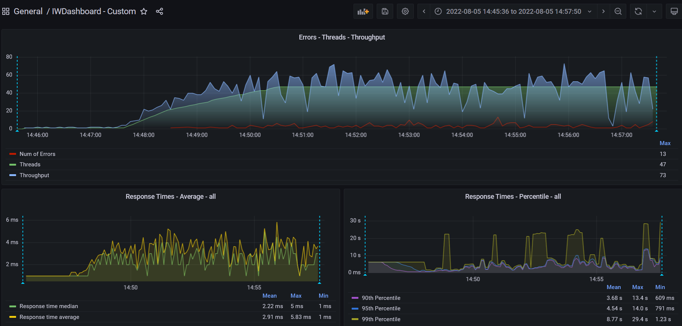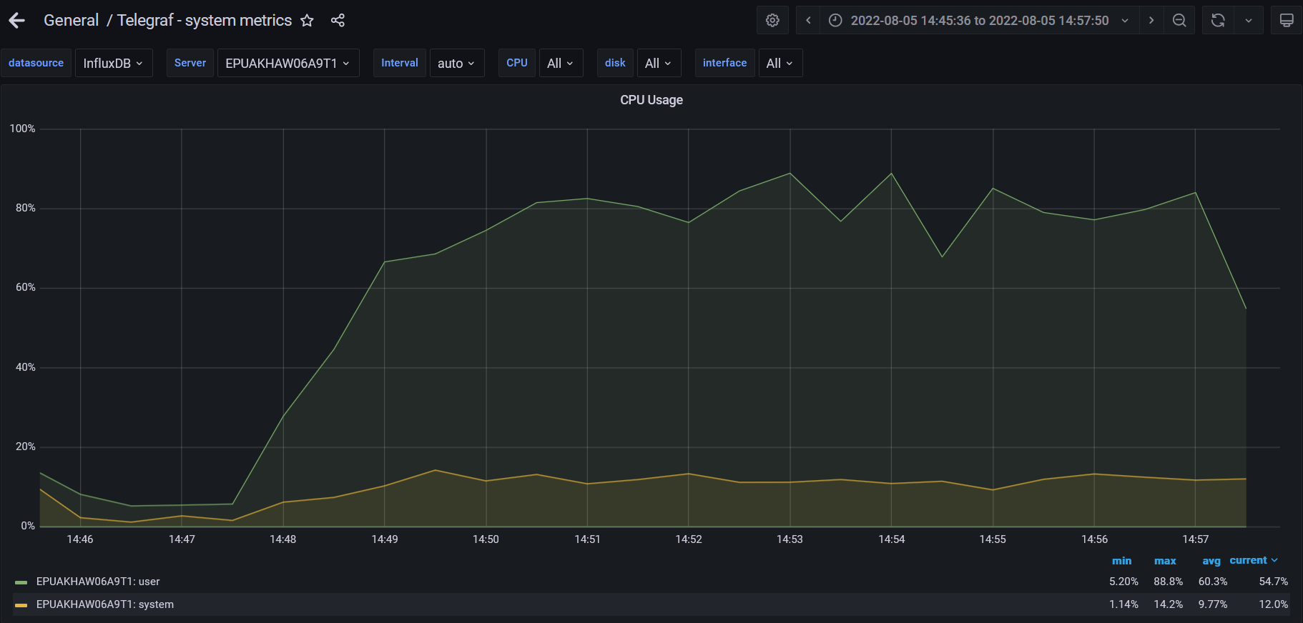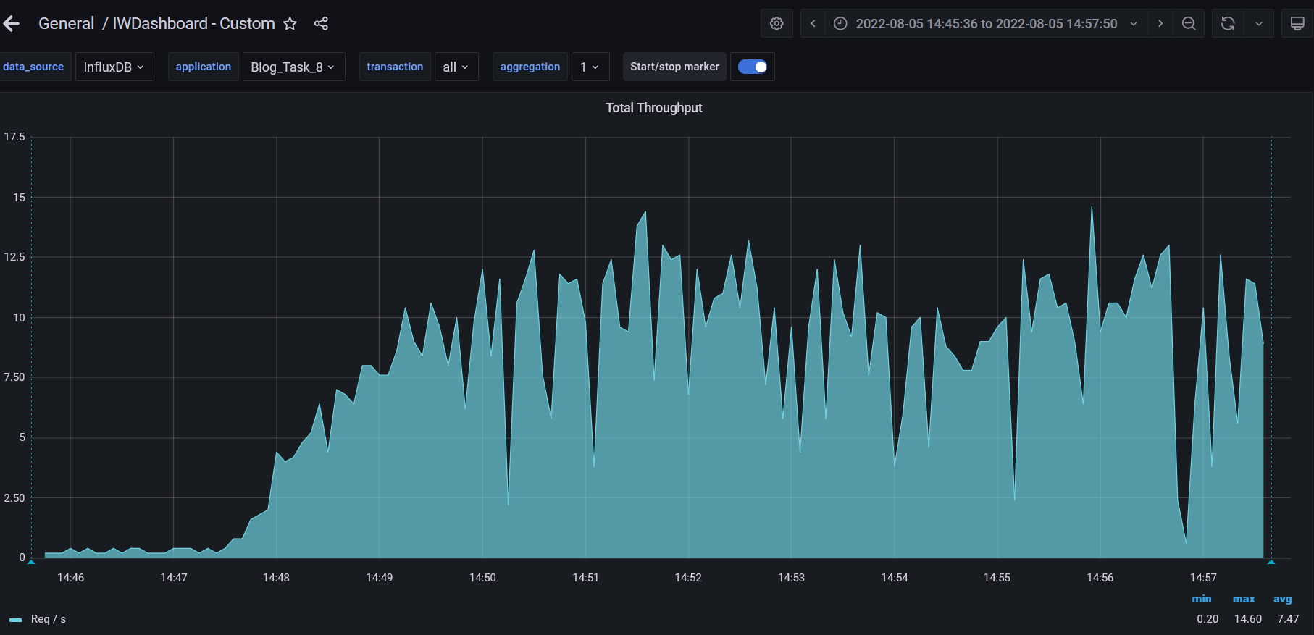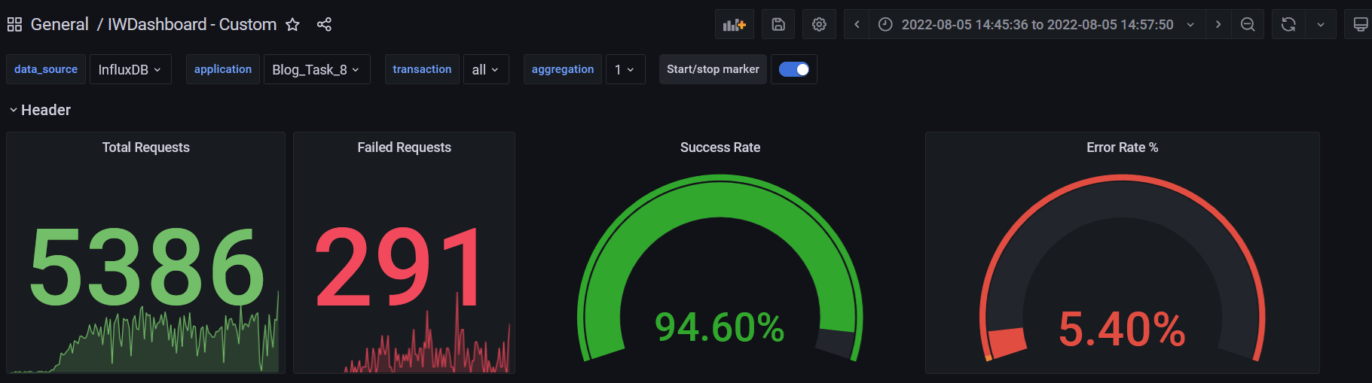

**Test Run #12**

**Detailed error report**

|  |  |  |
| --- | --- | --- |
| Response Code | Transaction | Error count |
| 500 | Transaction Controller (Edit Post)  Transaction Controller (Open Contacts)  Transaction Controller (Open Date)  Transaction Controller (Open Home Page Anonymous)  Transaction Controller (Open Large Calendar)  Transaction Controller (Open Post)  Transaction Controller (Open PredefineDate)  Transaction Controller (Open RandomDate)  Transaction Controller (Save Post)  Transaction Controller (Search By Name) | 1  2  3  9  3  2  14  4  64  14 |
| 400 | Transaction Controller (Open Home Page Anonymous)  Transaction Controller (Open Post)  Transaction Controller (Open PredefineDate)  Transaction Controller (Open RandomDate)  Transaction Controller (Search By Name) | 18  3  38  3  33 |
| Non HTTP response code: java.net.URISyntaxException | Transaction Controller (Edit Post) | 5 |

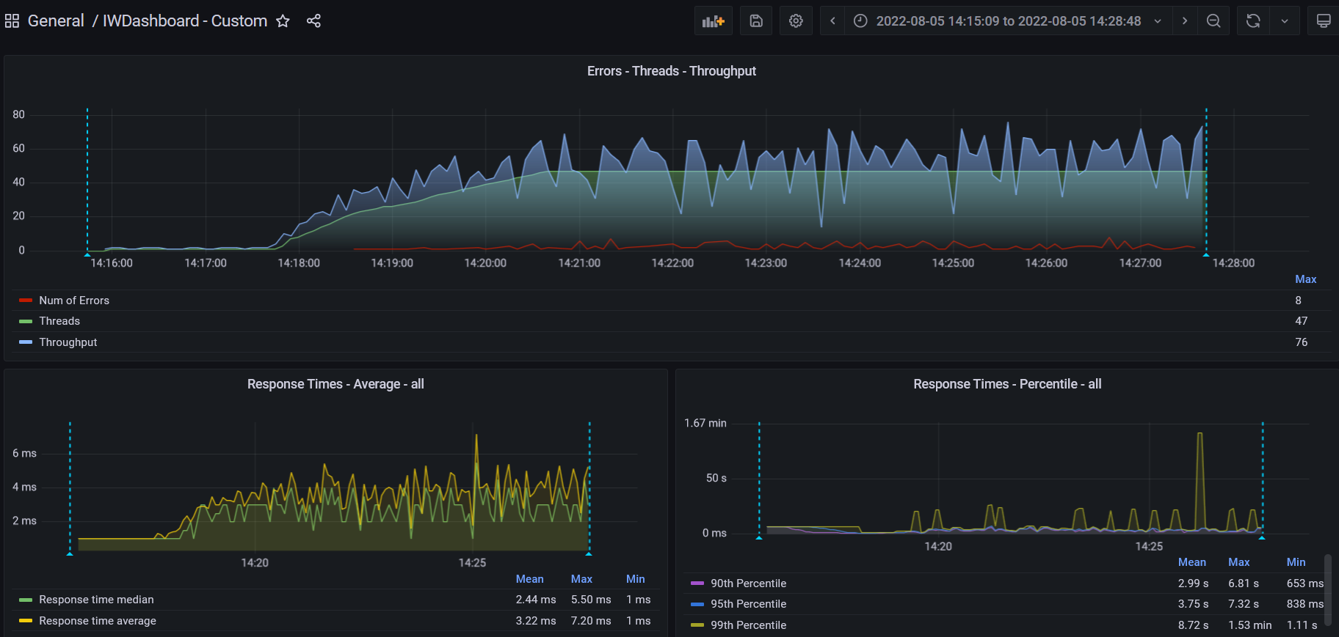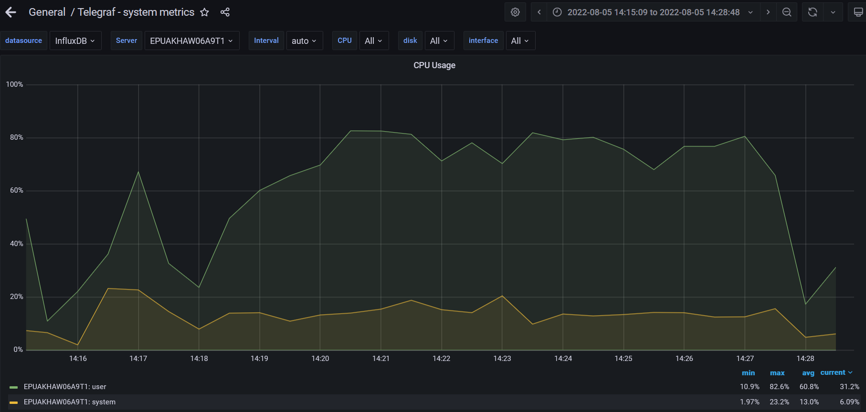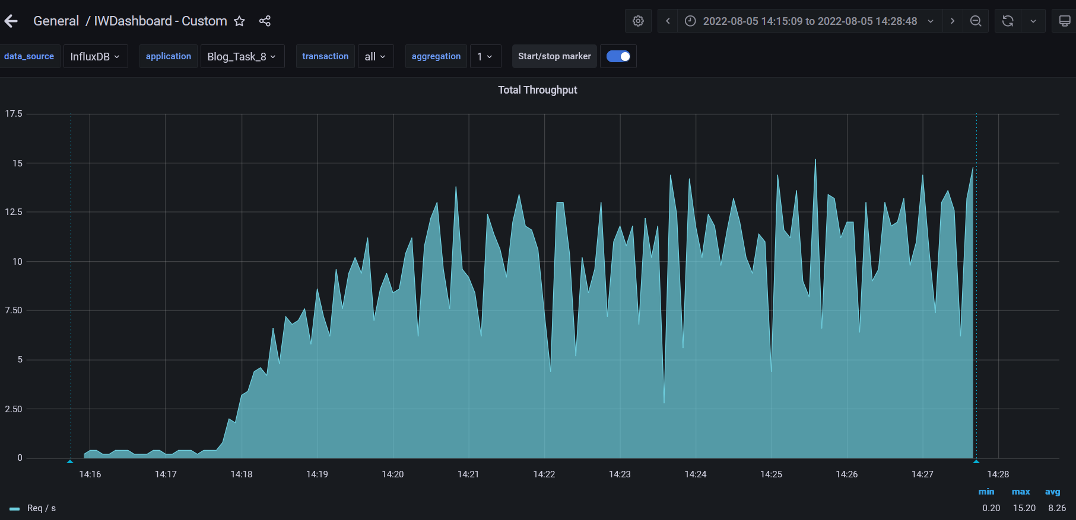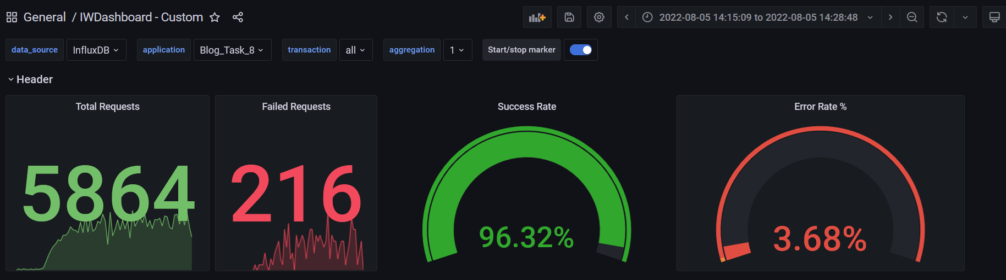

1. **Conclusion:**

The server worked stable according to the received test results. For the tests generated 5000 posts, and the combination of the test was divided by 6 configurations. The first part consists of 4th combinations of 100, 1000, 2000, 5000 without images, and 2nd part of combinations was defined as 1000 posts with images by 1MB and 2000 posts mixed: 1000 with images and 1000 with text. All scenarios were running 2 times for clarifying the results. Test result for 100 posts shows a lower "Error rate" of 0.02%. For 1000 posts with text and 1000 posts with images result shows an "Error rate" of 0.11%, for 2000 posts with text and 2000 mixed posts results show an "Error rate" shows 0.55%. In the case of 5000 posts the highest "Error rate" of 5.40%.